**Statement of Work for Financial Application Development**

**# Case Study 1:**

**Fidelity Go:**

Financial Advisor

* No fees taken (no trading fees, transaction fees, or rebalancing fees)
* Can start the investment from as low as 10$
* Less than 25000$ in your Fidelity Go account, you get an investment strategy depending on the amount of risk you are willing to take
* More than 25000$ in your Fidelity Go account, you get a personal finance advisor. Can have personal advisory on call, by saying your goals and plans, whether you want to clear a debt, plan to but asset or to increase your wealth
* Each year, they’ll check in with you to ask if anything major in your life has changed. If necessary, they’ll adjust your investment strategy to fit with your new situation.
* You'll pay no advisory fee for a balance under $25,000, or 0.35% per year for any balances of $25,000 and over
* On your 1-on-1 phone calls with a Fidelity advisor, You'll also get clear next steps so that you have tasks to complete and milestones to reach between each call.
* On a scale of 1 to 10 on taking risk, their most conservative play is 20% stocks and 80% bonds, their most aggressive play is 100% stocks according to our scale input
* There is no minimum investment to open a Fidelity Go account, if your account hits 10$, they will start investing for you accordingly
* Also has a robo advisor. Completely digital, can be accessed in laptop, smartphone, computer or tablet, etc. Speaks to the investment advisors that offer digital advice and account management services, often for a lower fee than traditional investment advisory services.
* They can review your progress during our calls. They will also send you monthly emails that show the investment activity in your account, as well as provide next steps and useful tips.

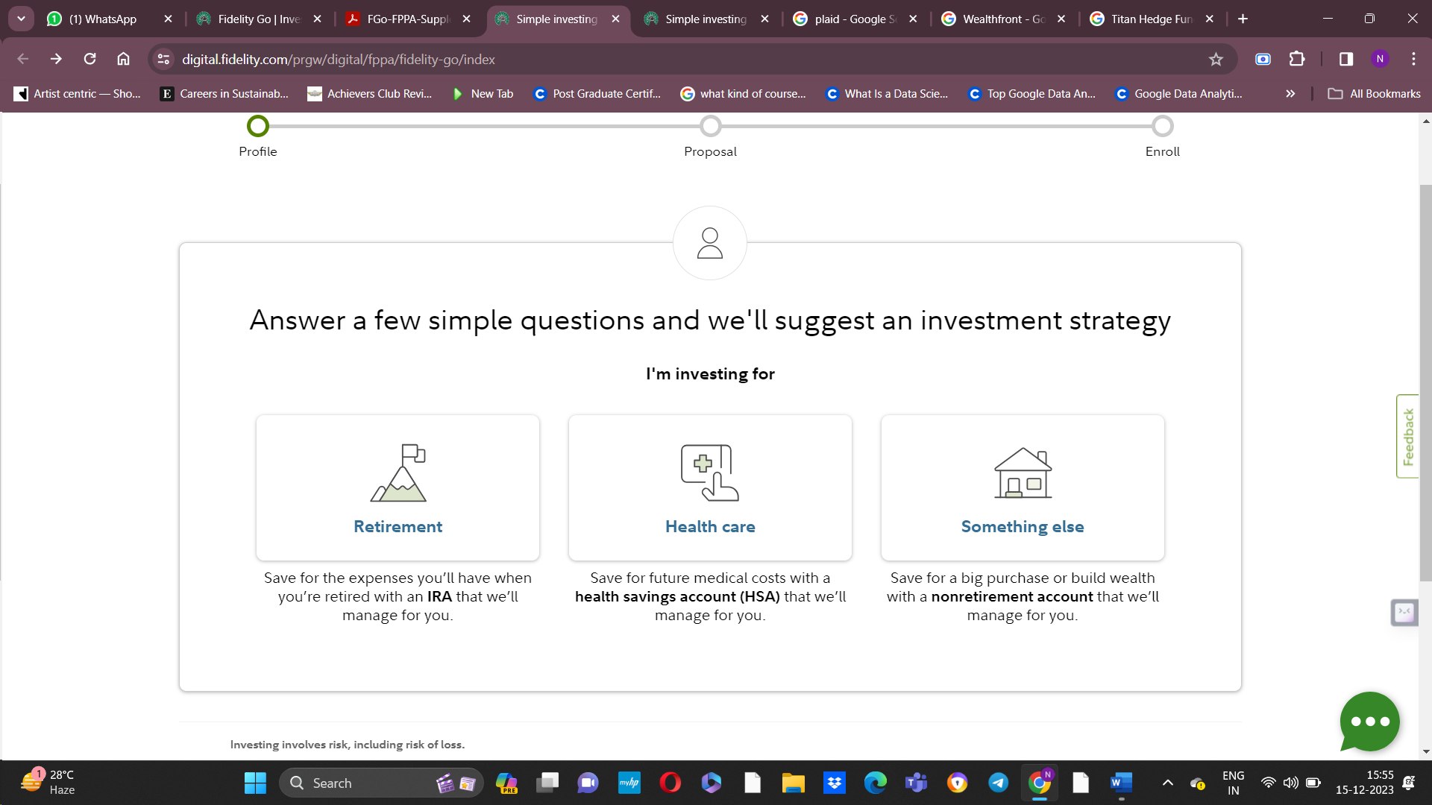

Inputs were: 1) DOB

2) Planning with a partner

3) Annual income

4) Money goal

5) Span of time you want to reach your goal

6) Initial deposit

7) Monthly contribution

1. **Something else:**

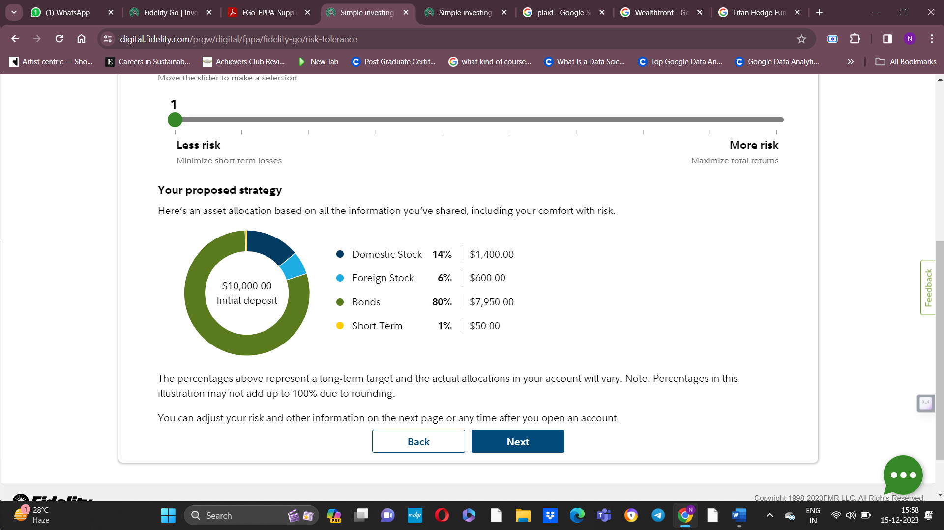

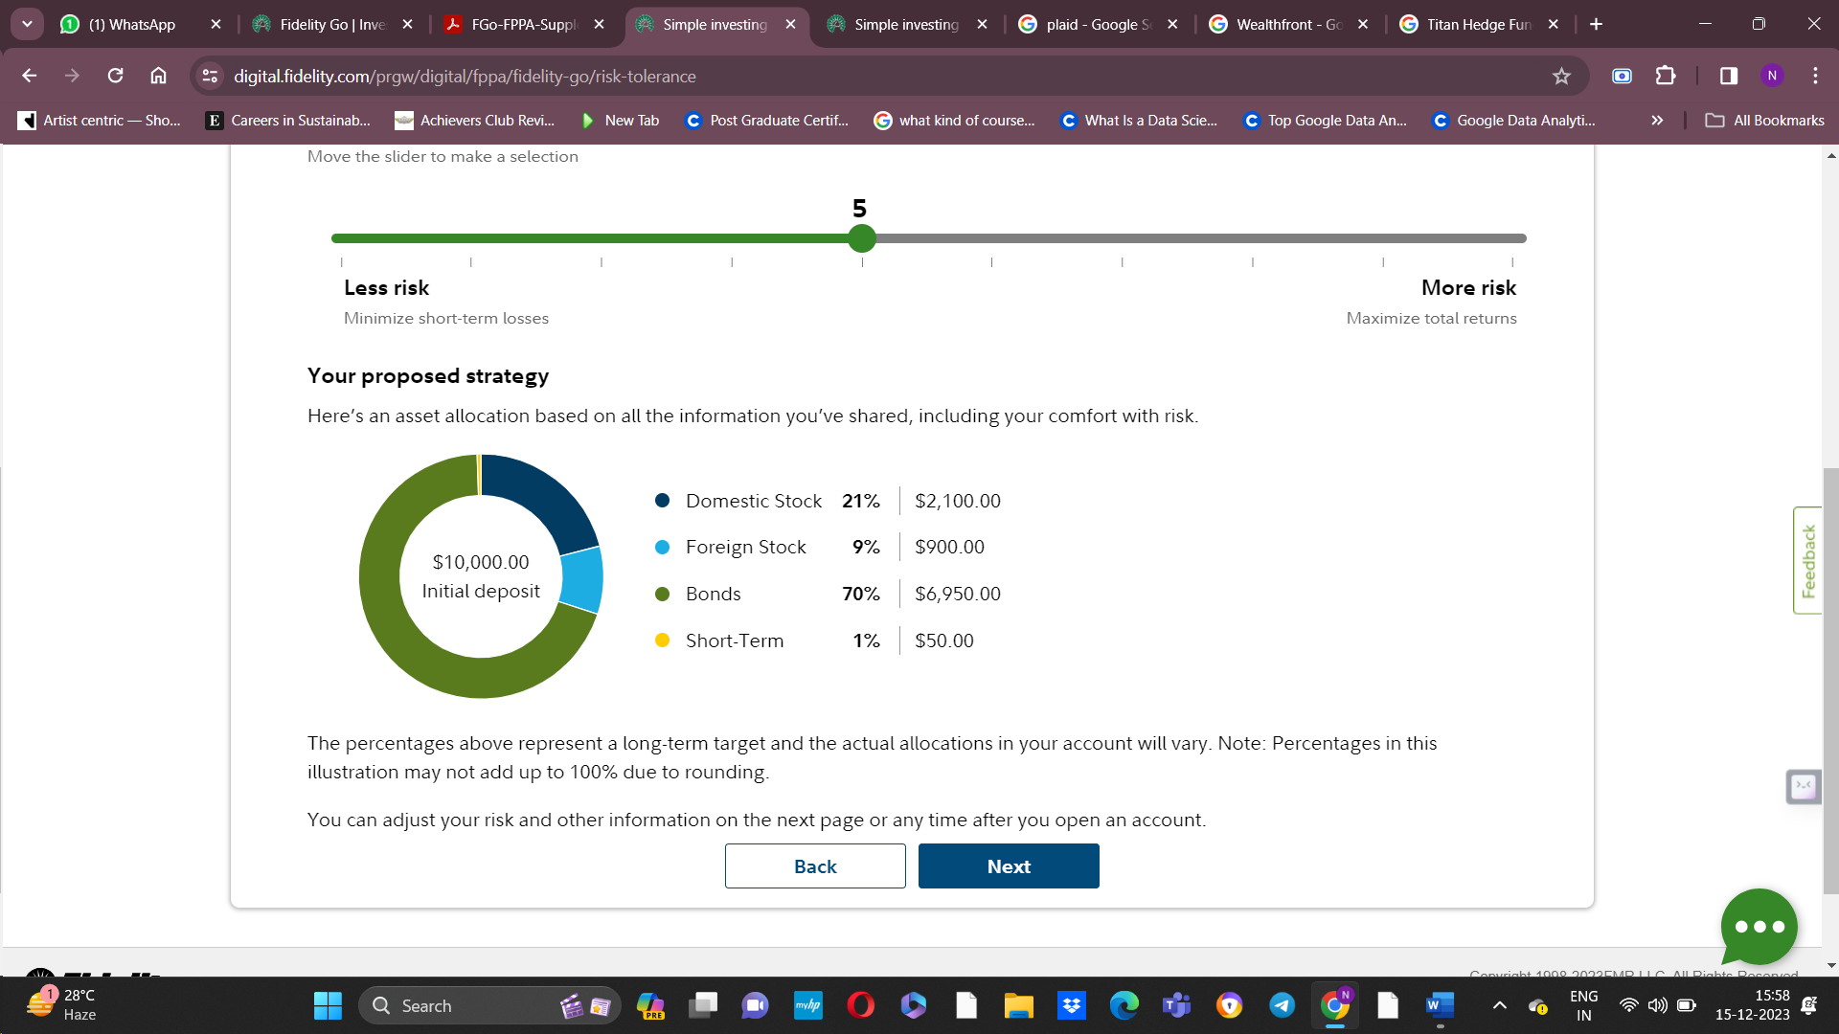

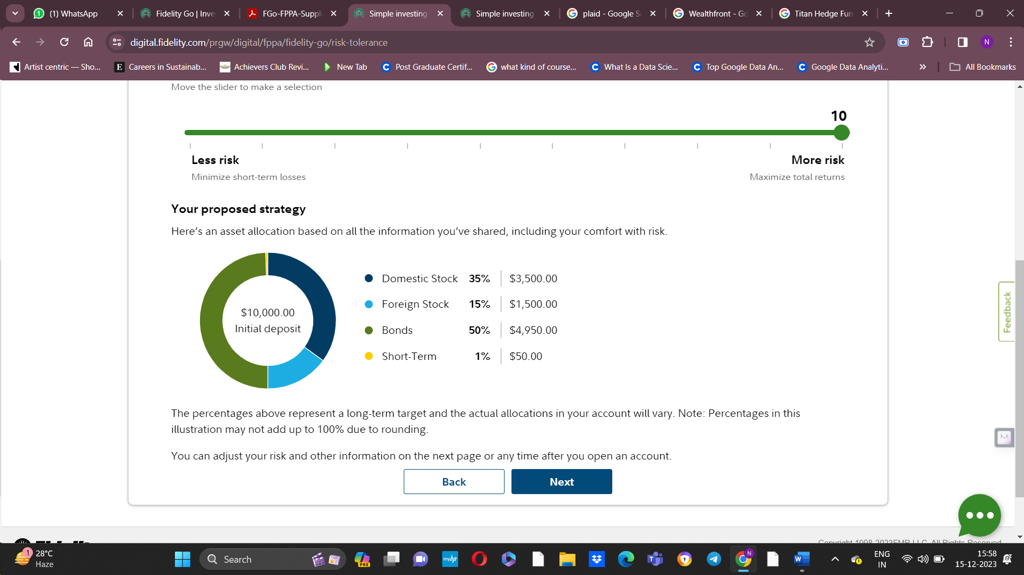

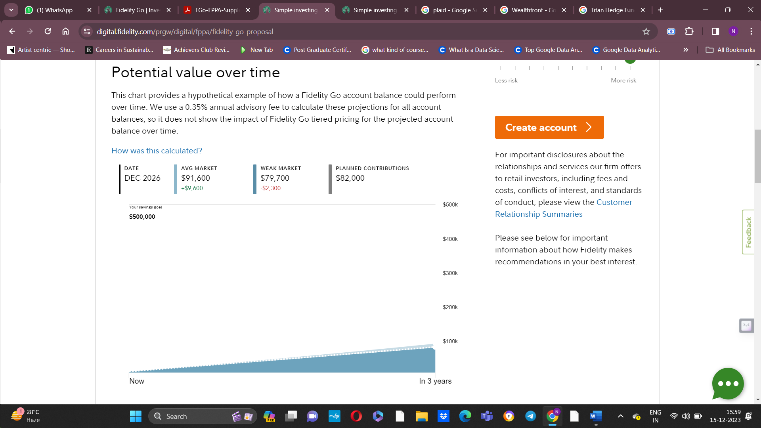

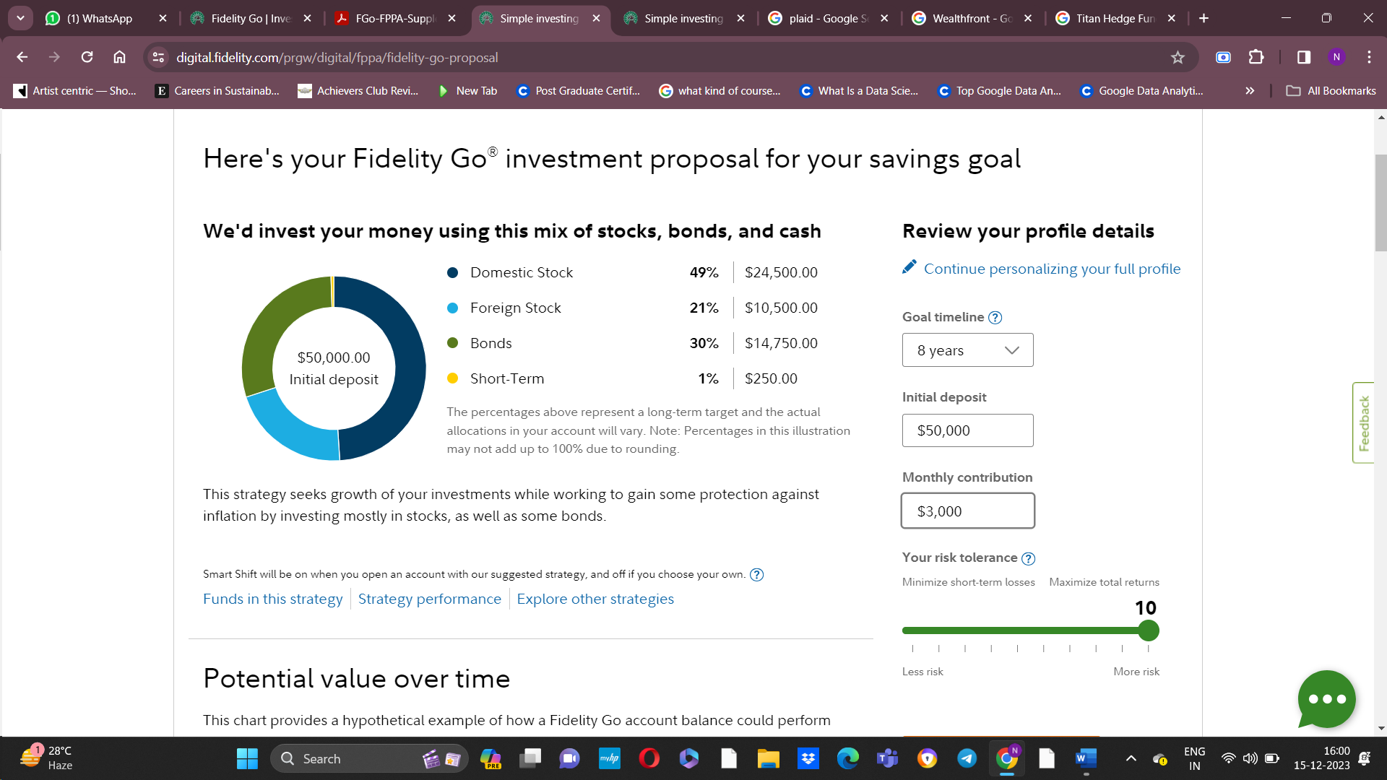

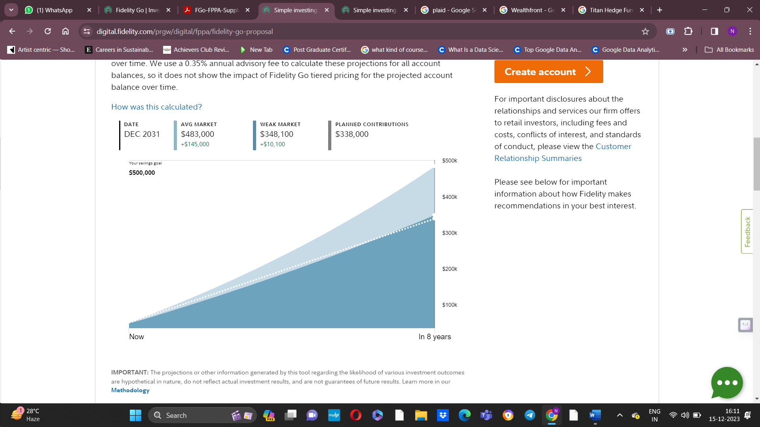

The "Weak Market" label on the chart means: In 90% of the simulations, performance was higher than Weak Market performance — and in 10% of the simulations it was lower.

The "Average Market" label on the chart means: In 50% of the simulations, performance was higher than Average Market performance — and in 50% it was lower.

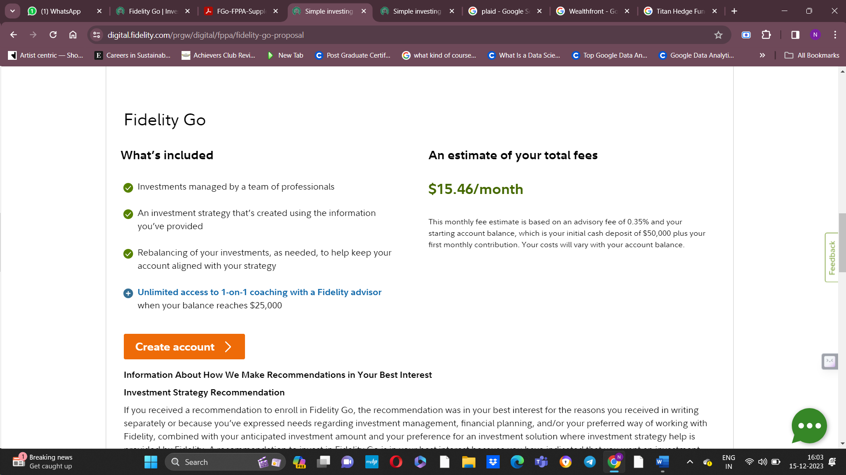

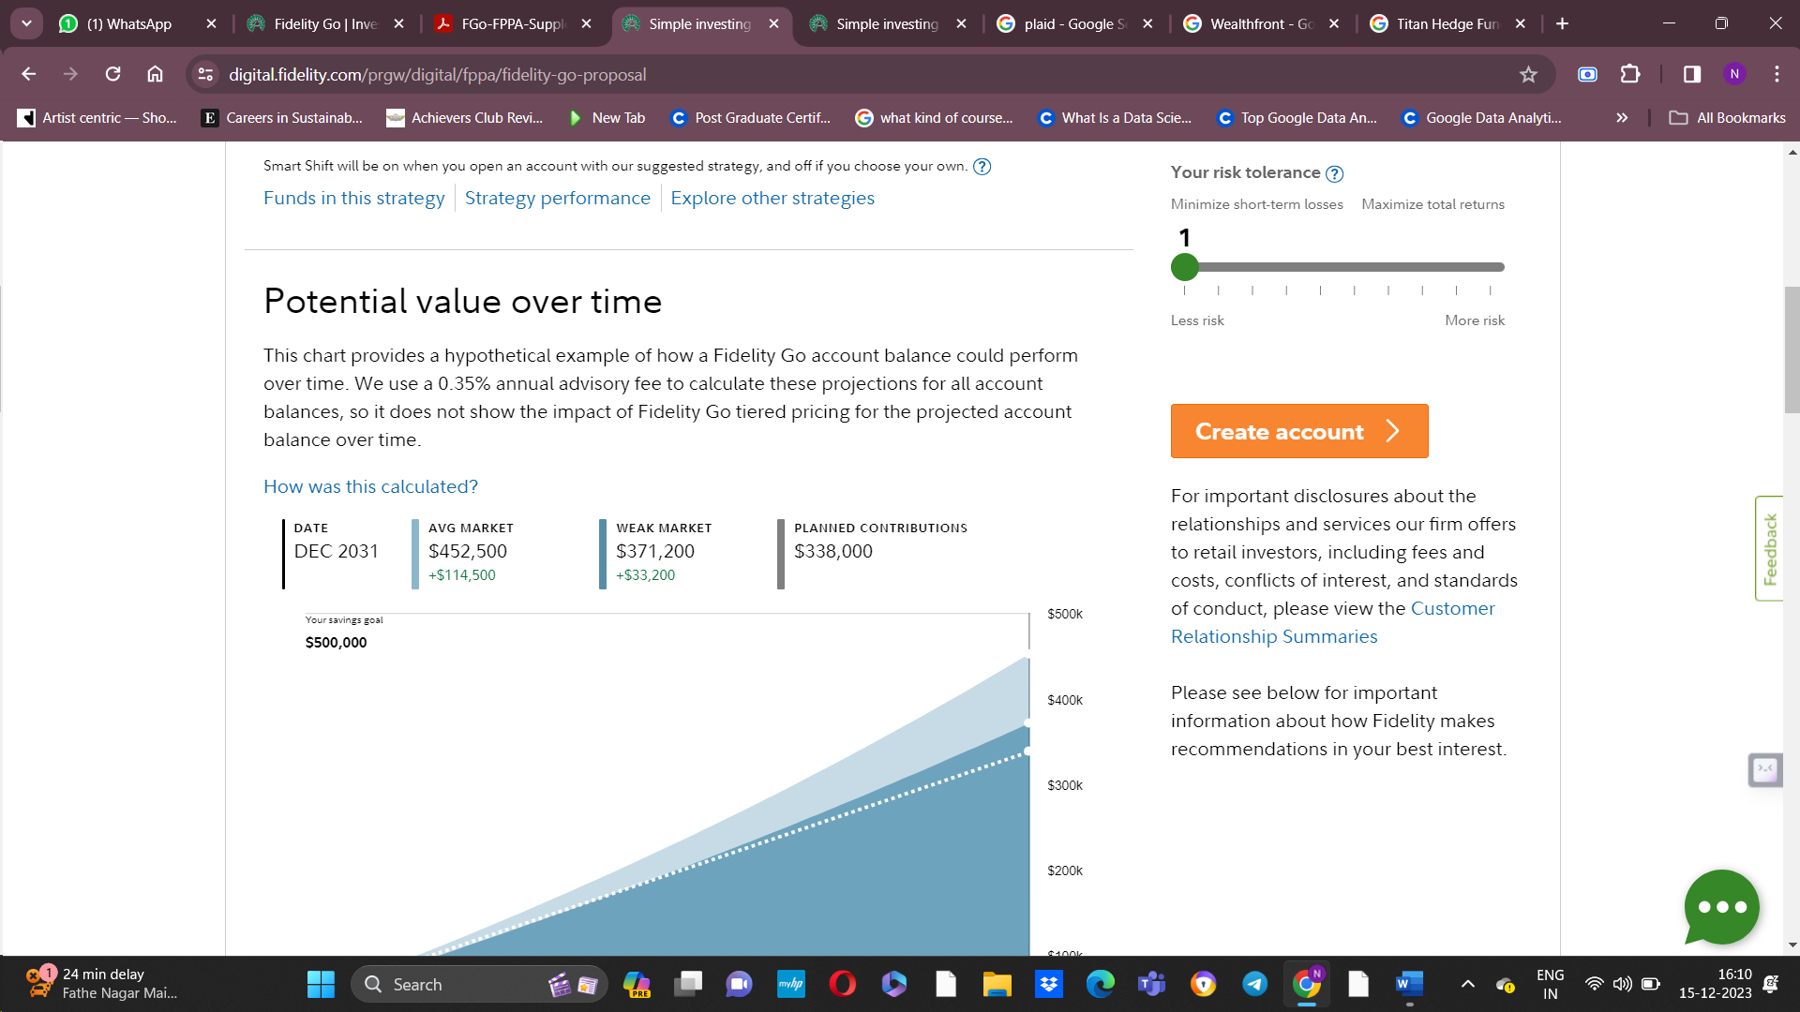

1. **Health Care:**
2. **Before Retirement:**

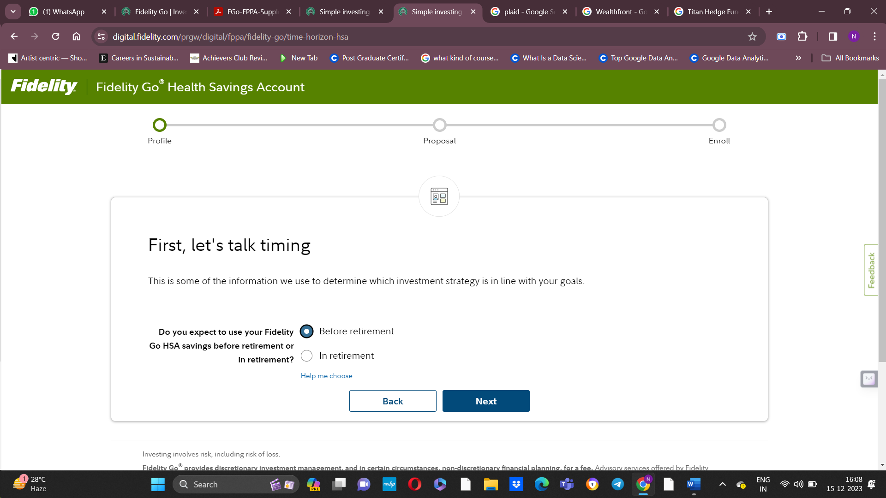

Same inputs as before

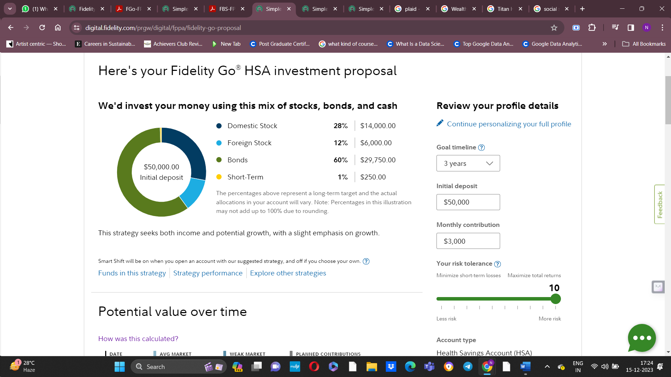

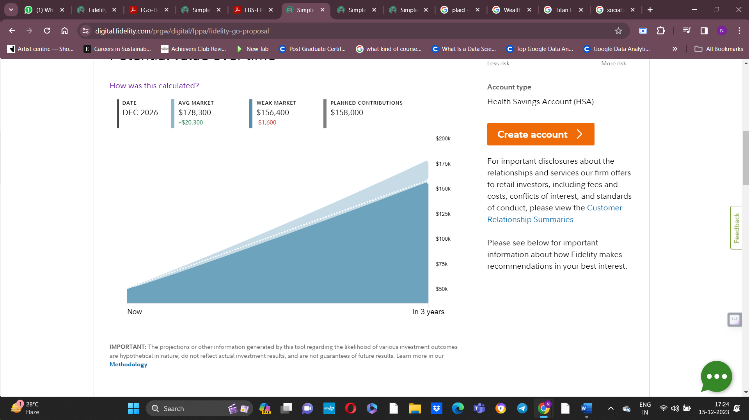

1. **In retirement:**

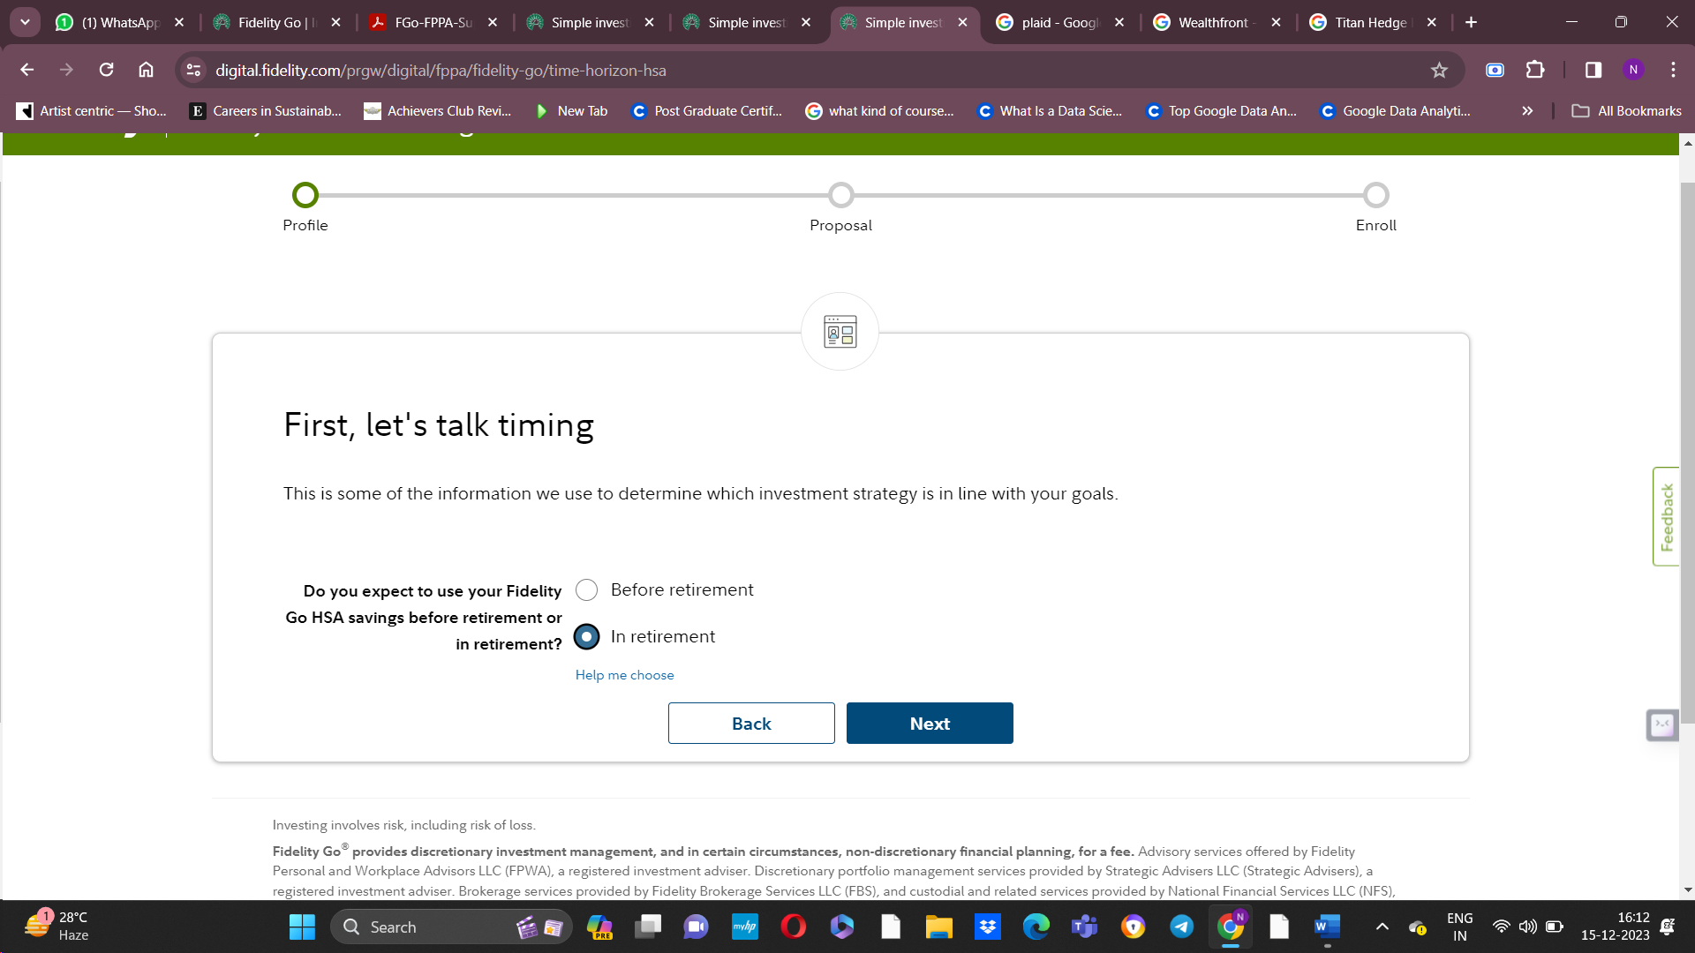

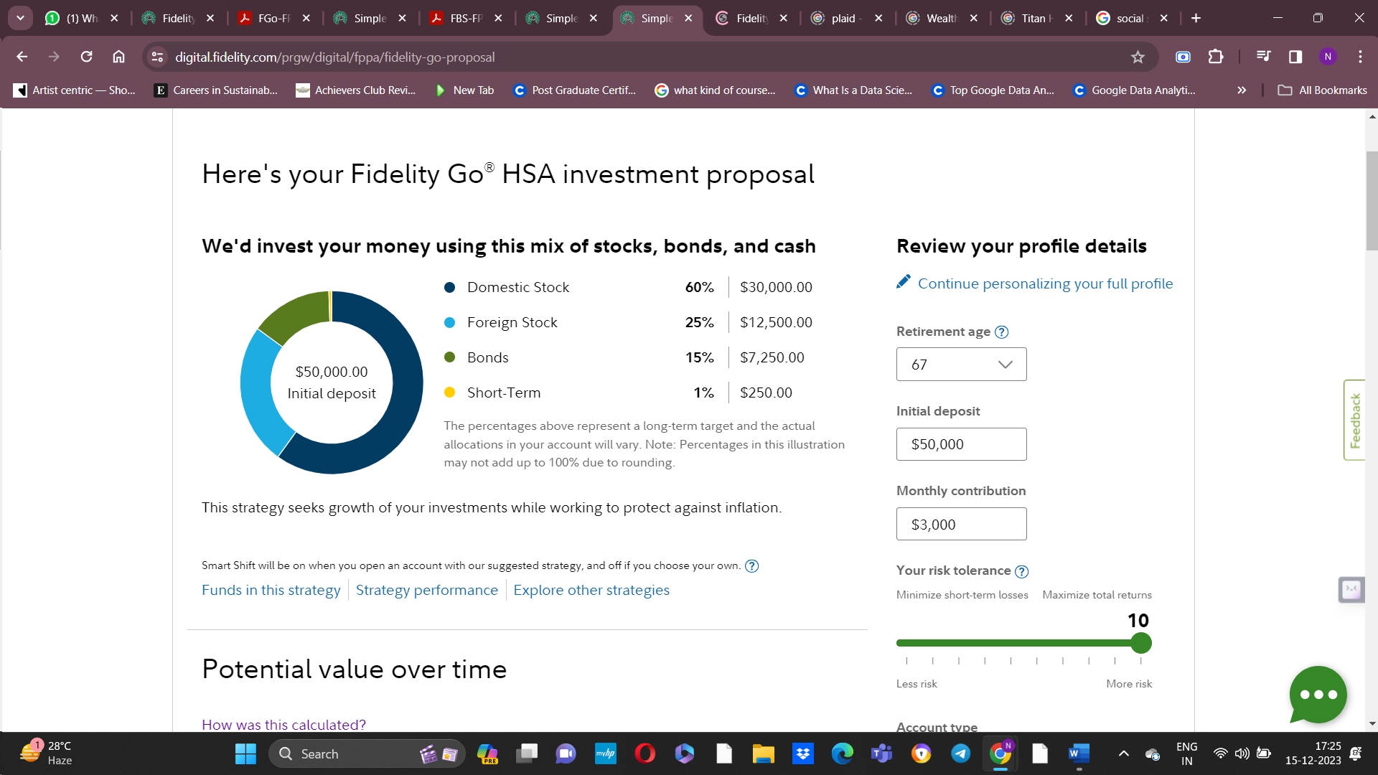

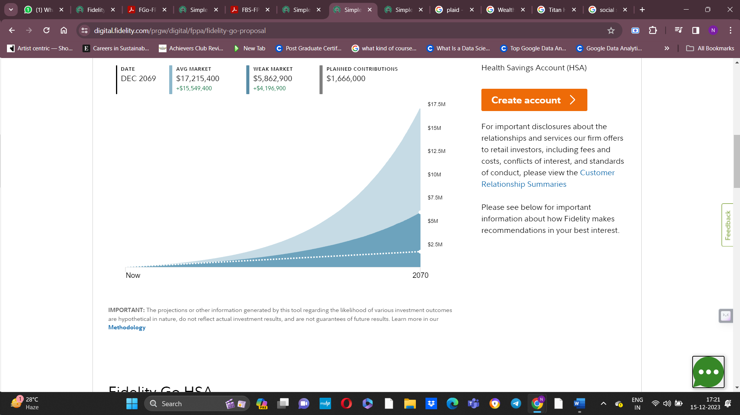

1. **Retirement:**

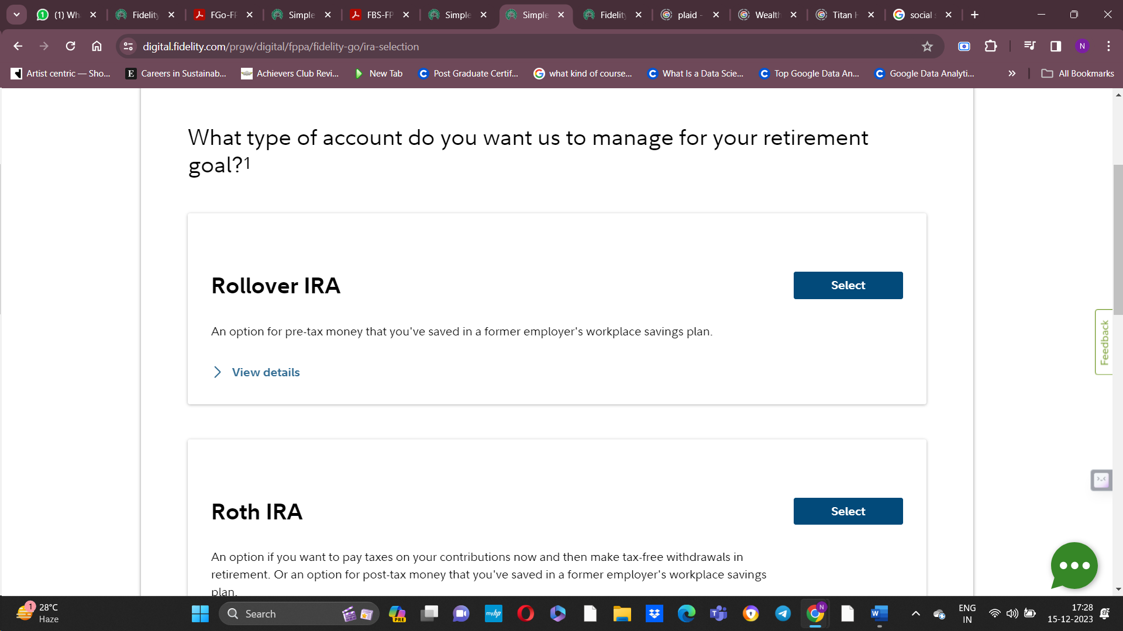

**Creating an account:**

Couldn’t because Social Security Number and ZIP code was mandatory

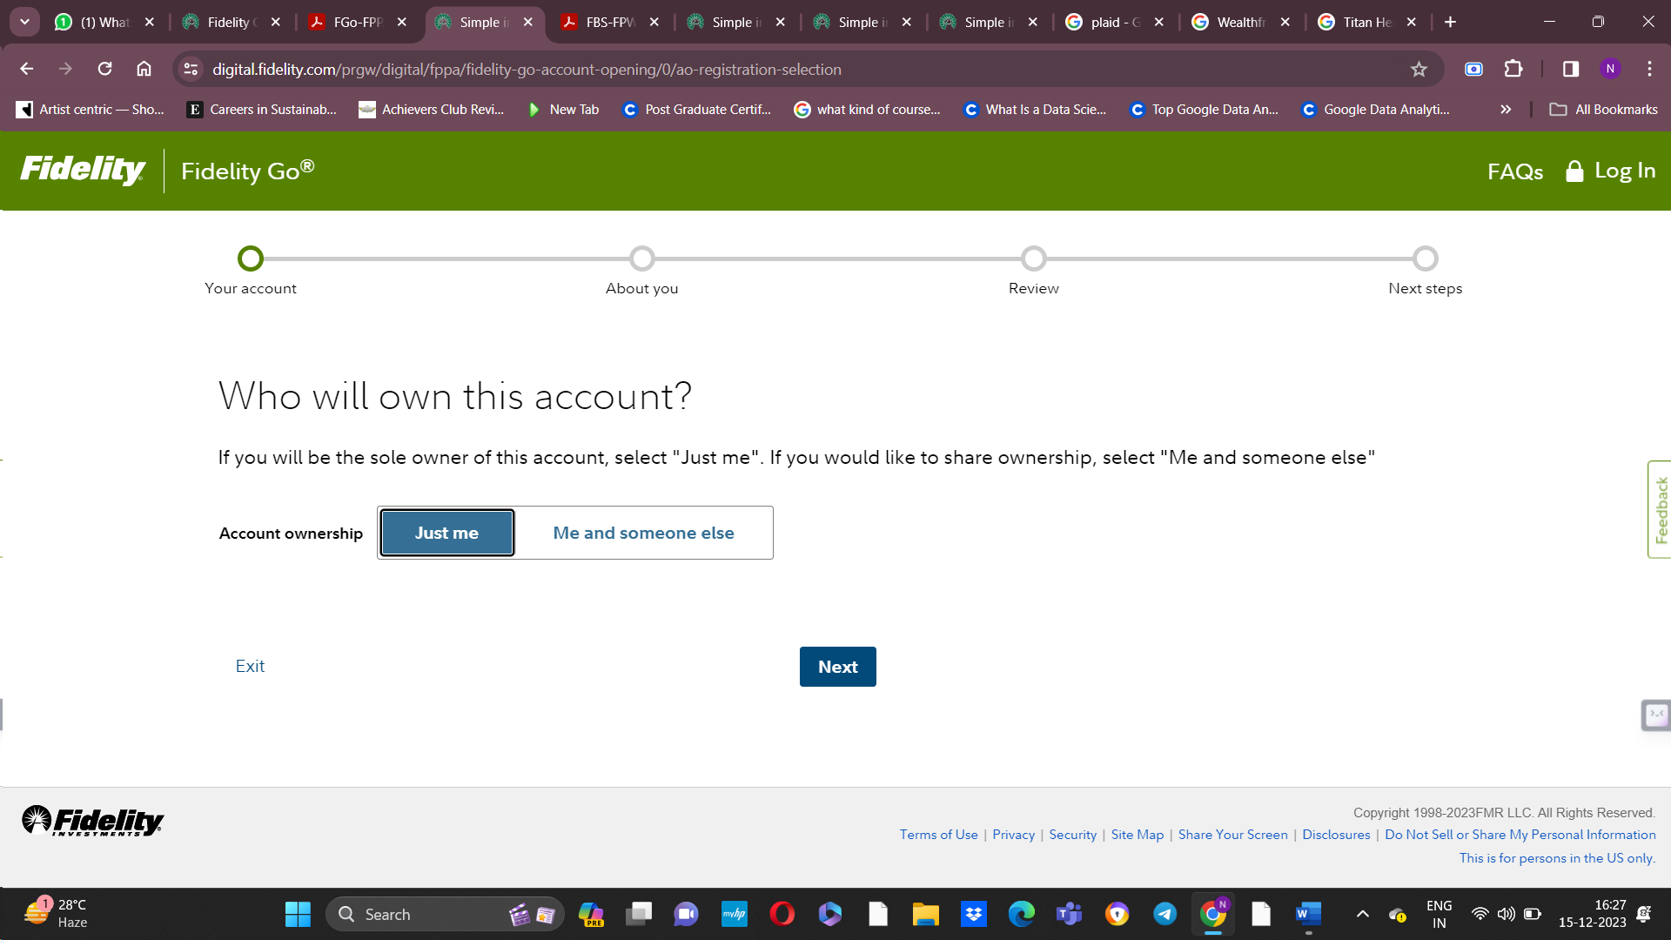

**Plaid:**With one single set of APIs, your application can talk to 1000s of banks, which lets you do everything from

* Fund your own app accounts,
* to help your costumer apply for loans,

The software offered by plate acts as ago-between for your bank or credit card accounts and the mobile applications offered by other financial institutions

Some finance apps or websites do need your financial information to function which is understandable but if you don’t want to give your login credentials to every finance app or website, you can use plaid.

(For eg, financial aggregator needing access to your investments or a budget site accessing your bank and credit card transactions)

When you need to pass your bank credentials to another finance app, you’ll be prompted by a plaid window, you will enter your bank’s username and password and submit the form. That information stays with plaid, it contacts your bank, and verify your login information, if you have setup 2fa you will enter that information as well. Plaid also has an option to use its own 2fa if your bank doesn’t support that extra layer of protection

Once you have used plaid and authenticate your bank information, the connection is in place and can be used to transfer the financial information that you authorize. This could be information like transaction history, balance or any other information

Is plaid safe to use?

Plaid says it takes the security of the costumer’s data very seriously. Plaid uses encryption protocols like the advanced encryption standard AES 256 and transport layer security TLS when transimitting financial data. It also uses multi-factor authentication mfaa to further secure your account if your financial institution doesn’t offer it. It promises to never share your data without your permission and never sell or rent your information to other companies. It allows to control over which companies have access to your data and what data is shared with each company.

But how to talk to Plaid API?

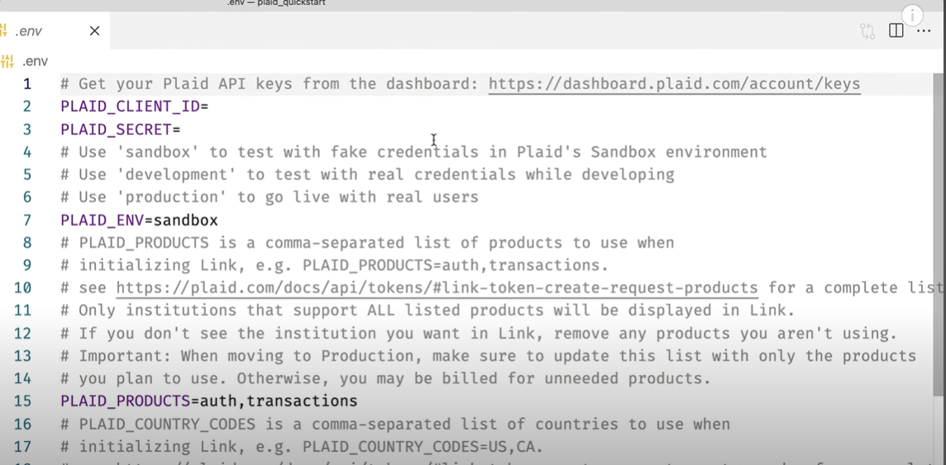

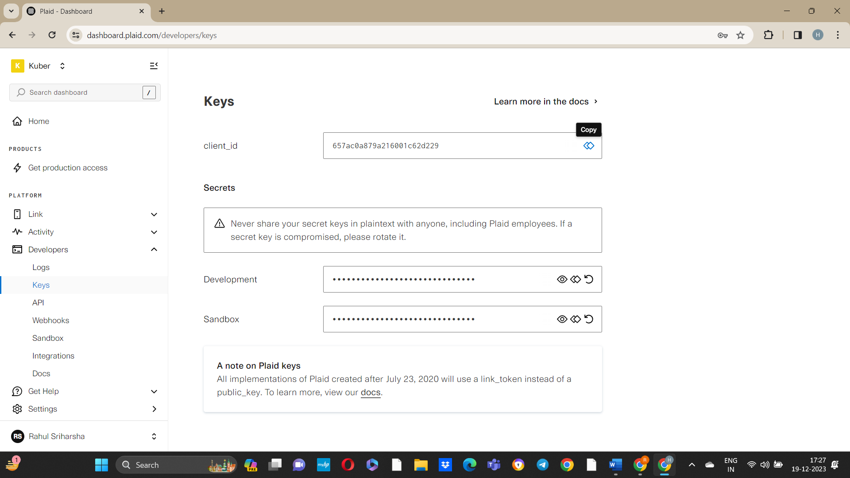

Sandbox: Basically, used for development purposes. Nearly unlimited use of all Plaid products for free but you’re not touching any real data. All the data I will be reading will be fake, and I won’t be actually affecting any user data

Development: Used for development purposes using real data but with a small pool of trusted testers or maybe just your dev team or something

* Like Sandbox mode, its free to use but you are usually limited to 100 logins
* Upgrading your account to development will take about a business day, you have to fill a form

Production: When you want to use plaid products in the real world. You have access to real data, and there aren’t any limitations like that of development, but you should start paying for the products that you are using

* Approval for this also take some business days and I have to tell more about the company, and how I am planning to use the plaid API, and so on

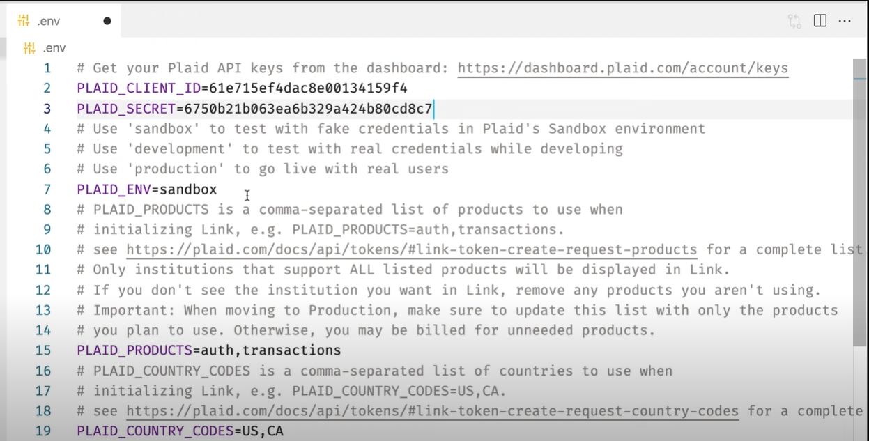

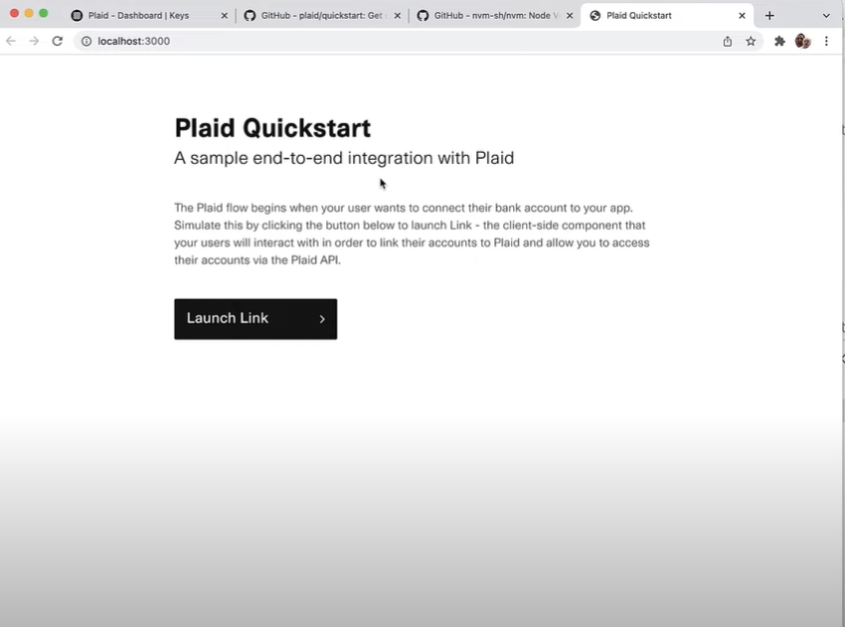

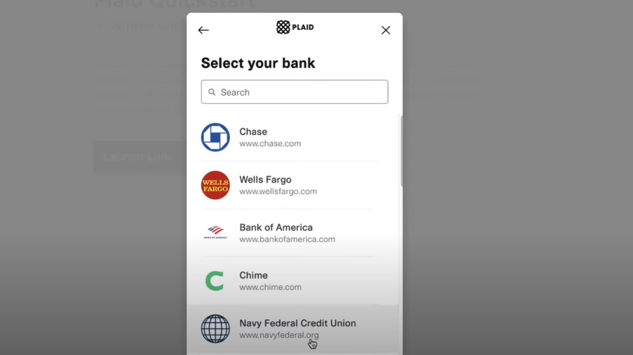

As this is a sandbox environment, we won’t actually be talking to these banks for real

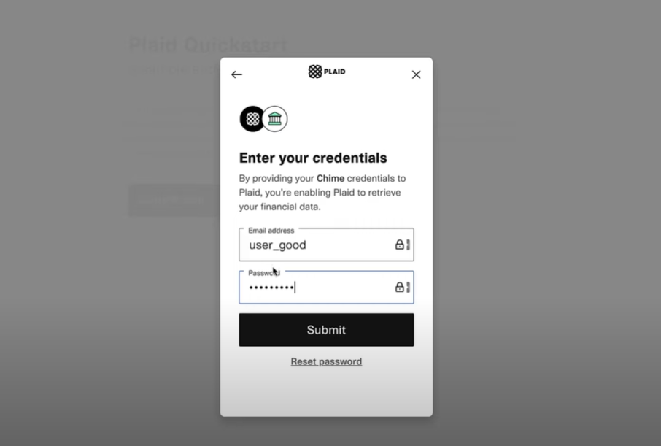

Username: user_good,

Password: pass_good

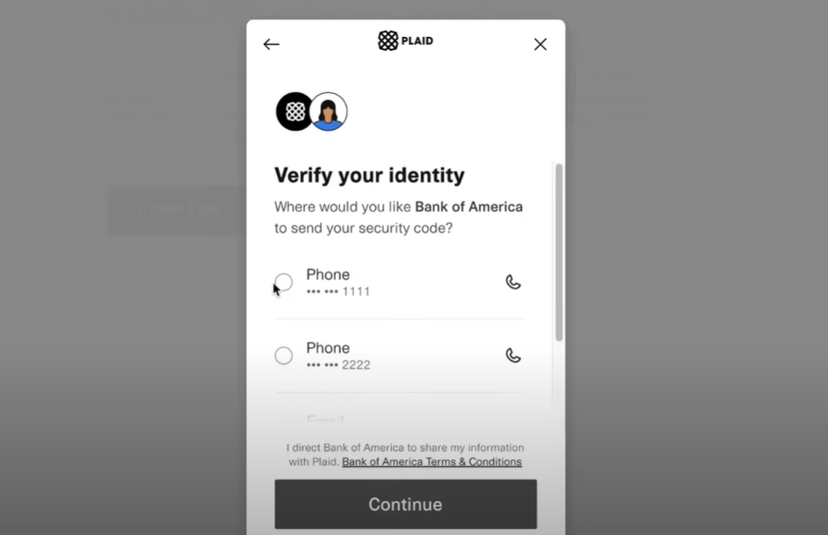

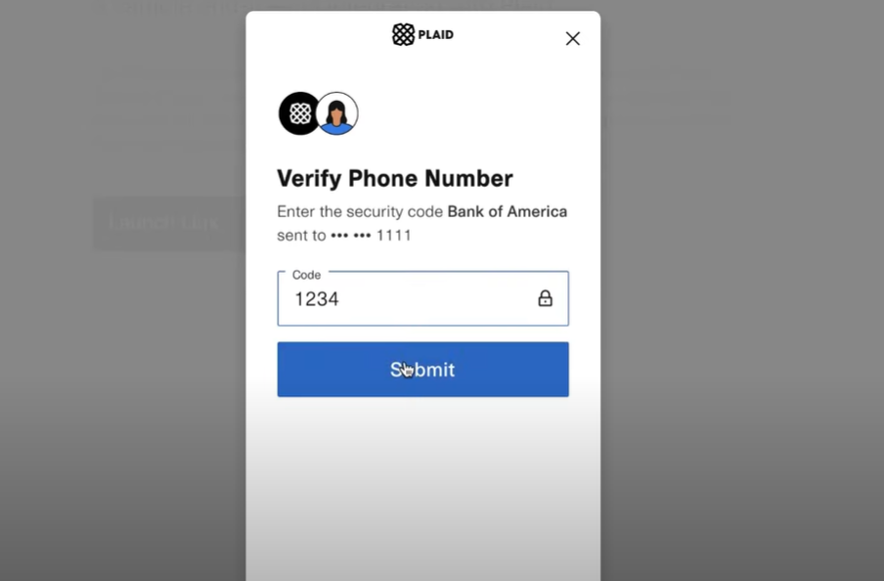

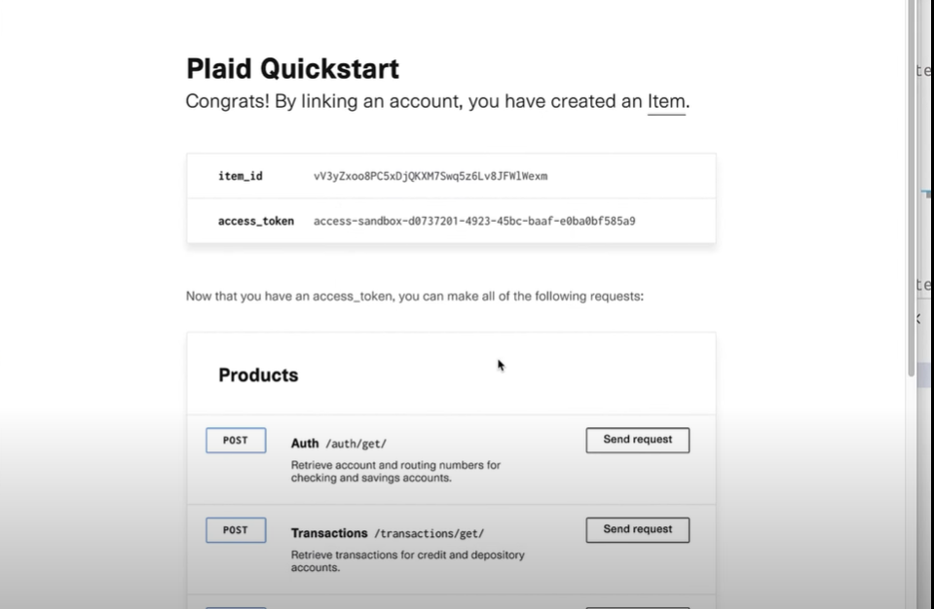

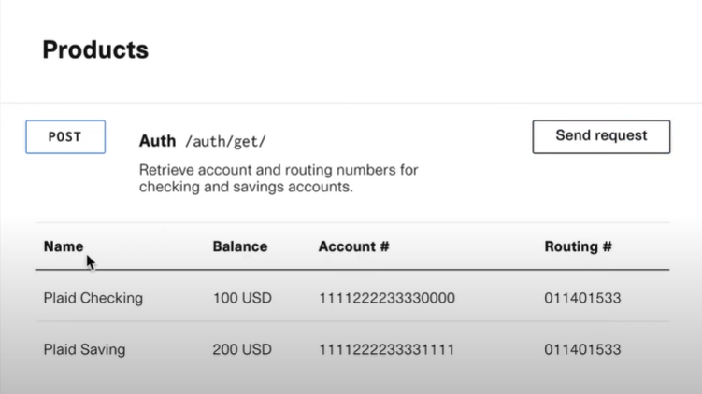

This info you might need for tasks like transferring funds

**Plaid Auth:**

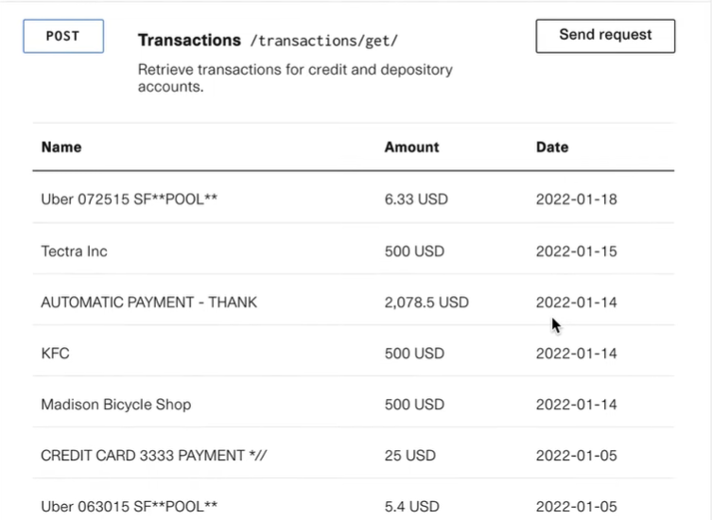

This is info is useful if you are building some budgeting software

**Plaid Transactions:** Fetches transaction data for credit and depository accounts from tens and thousands of financial institutions. This can be used to build an understanding user’s financial health, so they can manage their cash flow, reduce expenses, create budgets, and more.

Have a transactions/sync option so that you can have more streamlined view of the transactions that have been added, modified or removed since you last called it

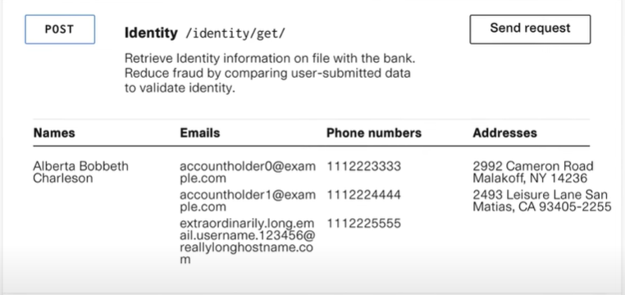

Retrieves user’s info as verified by the bank. This is great if your user is applying for a loan or adding money to your app, and you want to make sure they really are who they say they are.

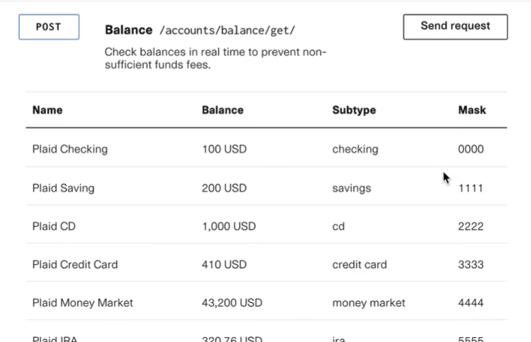

Will get you a list of account balances, “updated in real time”. This is useful if you are building, like, a peer-to-peer payment app, and you want to make sure your user has enough money in their bank account to cover a transaction

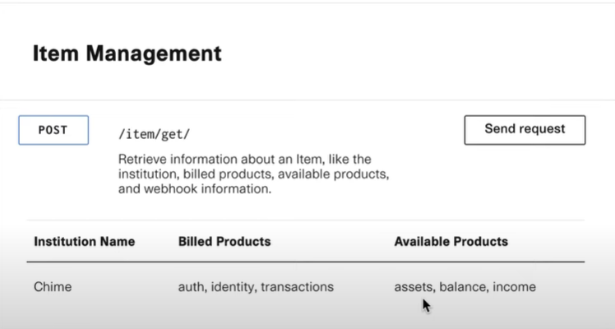

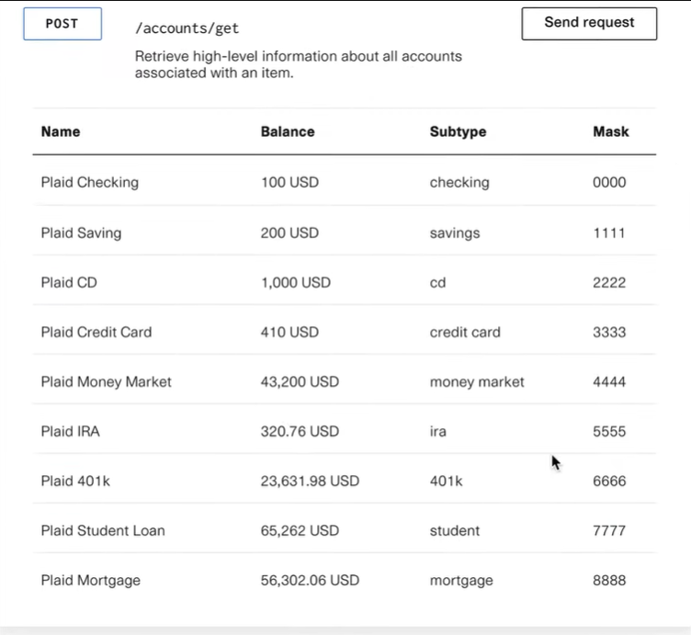

Gives information about the all type of accounts that are stored at this institution

This almost looks same as the balance data. It’s true because we are working with a fake data, but in practice this accounts data will be several hours old but the balance data will have more real-time information

|  |  |  |  |
| --- | --- | --- | --- |
| Features | Useful | Acceptable | Not so useful |
| Multi factor authentication | Yes | No | No |
| Safe keeping user’s bank information using encryption protocols | Yes | No | No |
| Different environments to test | No | Yes | No |
| Dividing the user accounts information | Yes | No | No |
| Updating Transactions | Yes | No | No |

**Wealthfront:**

Completely worked by Robo Advisors

0.25% fees for the wealthfront service

Additional stock fees will also be there (the percentage depends on the stocks)

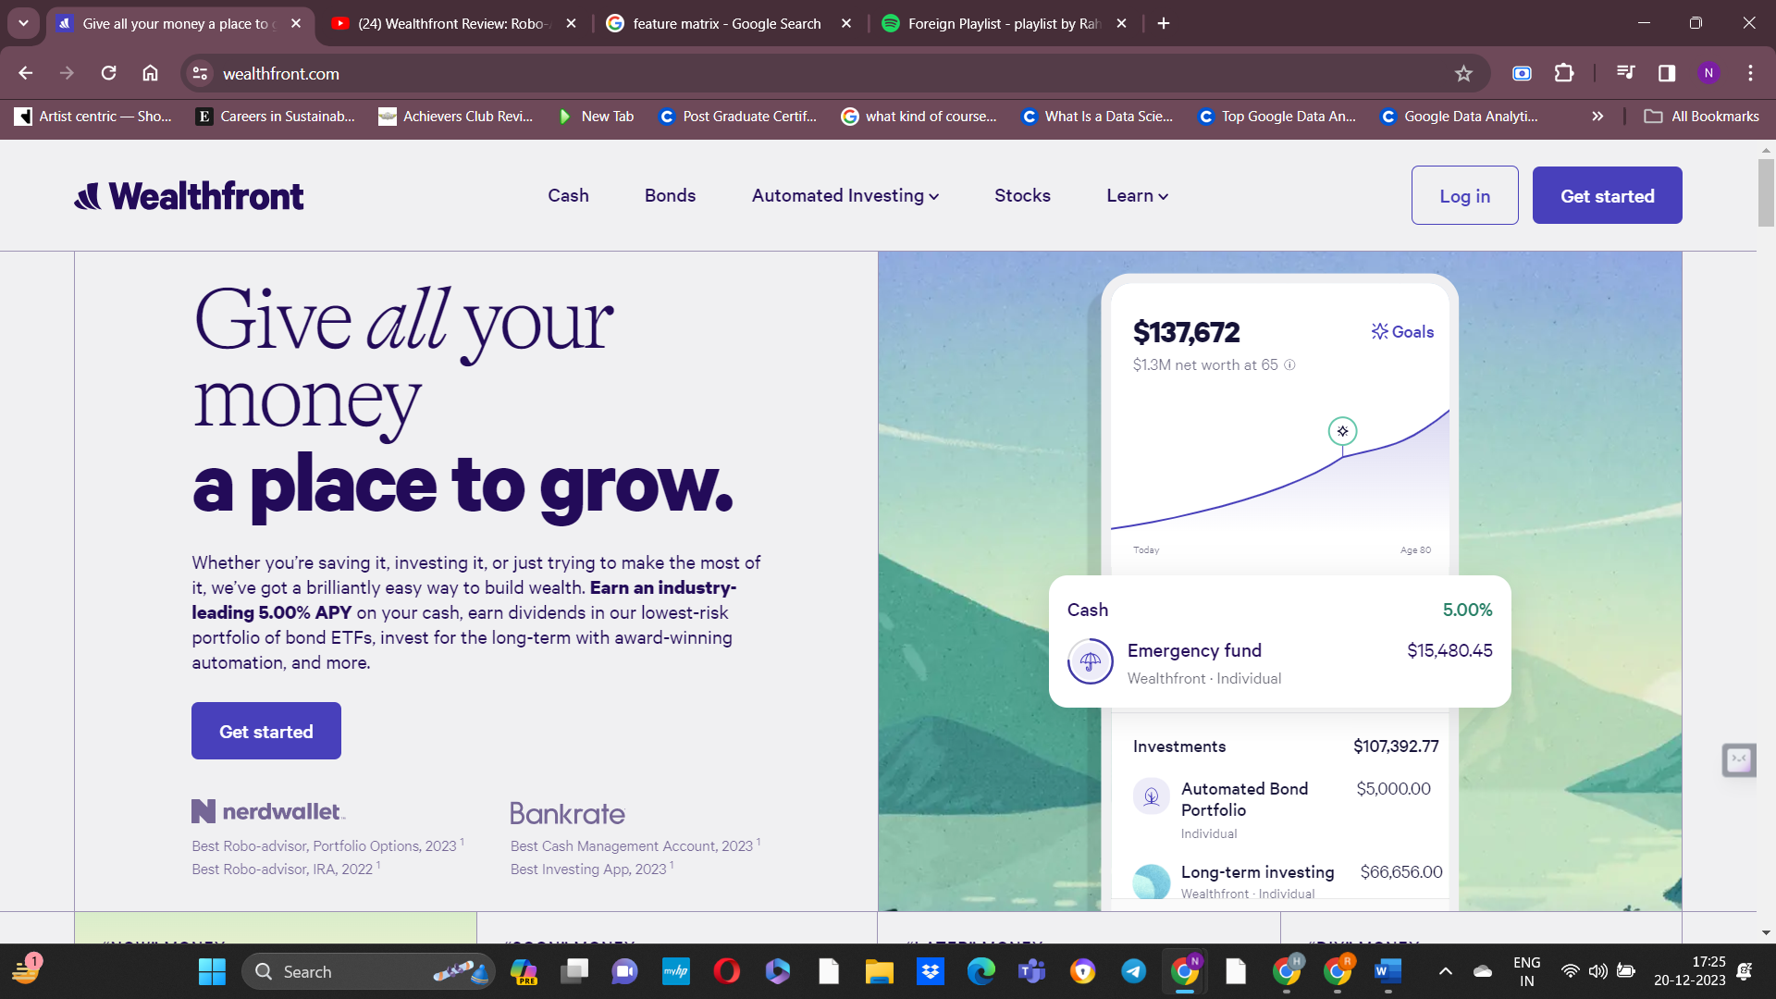

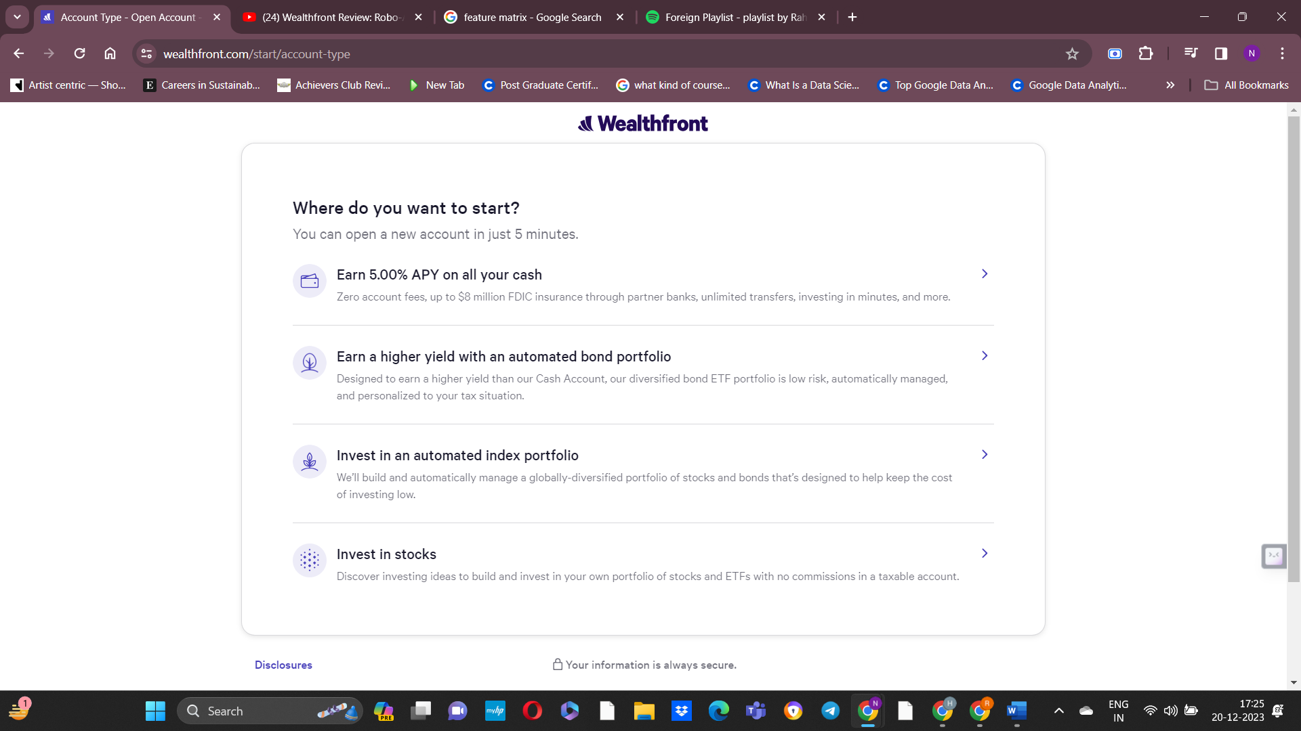

I chose investing in stocks:

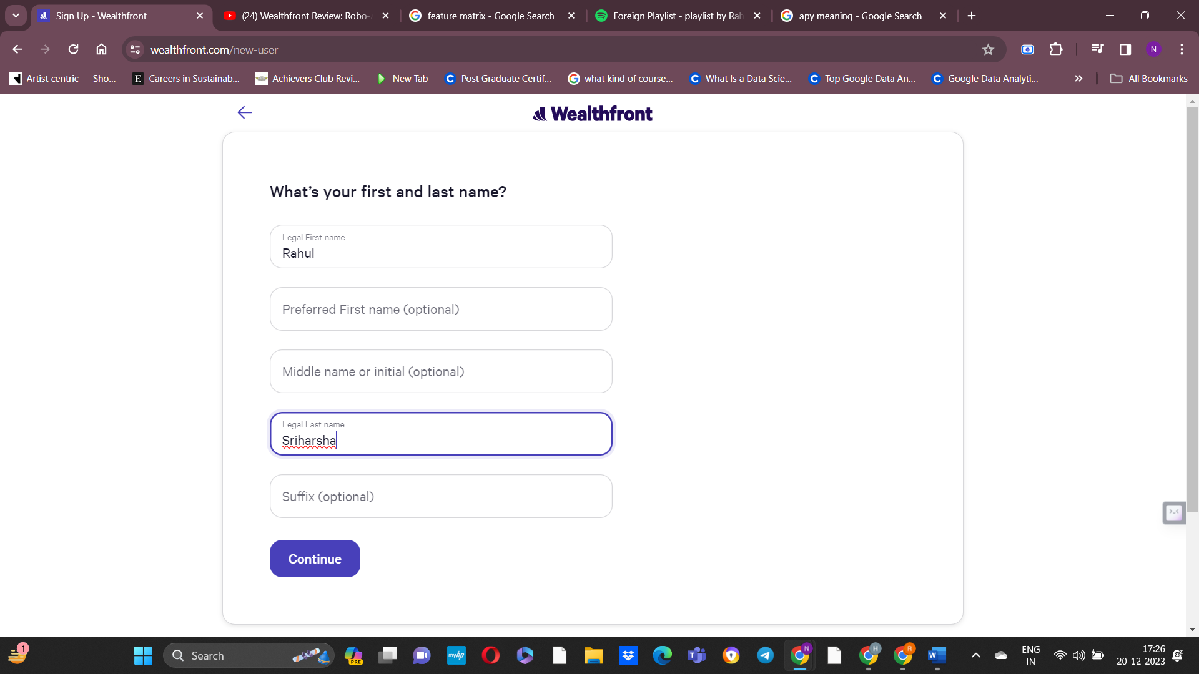

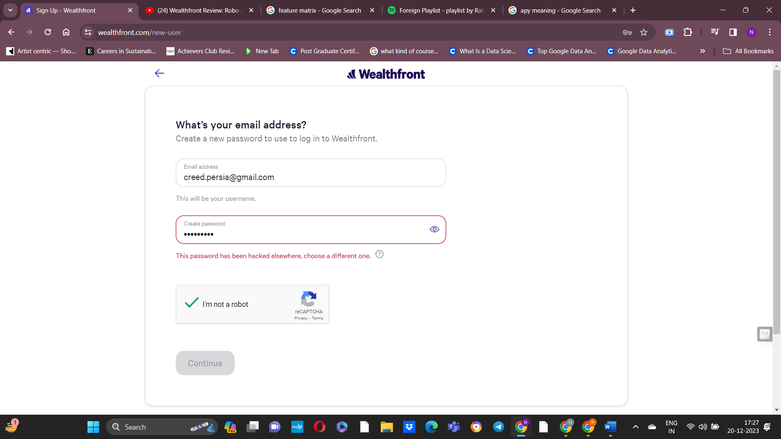

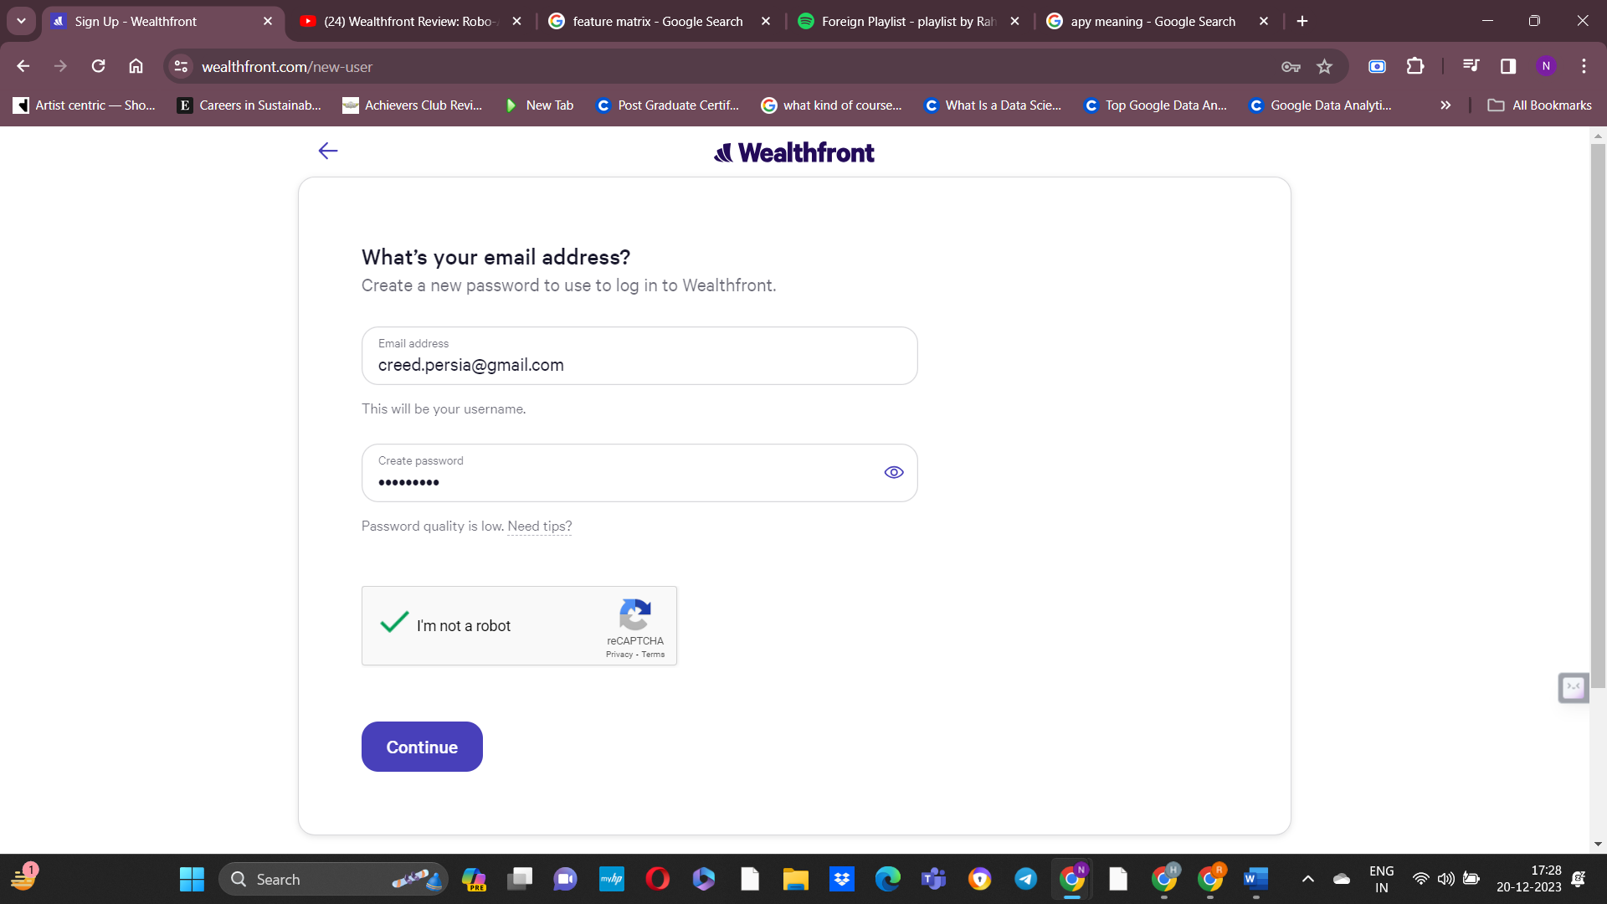

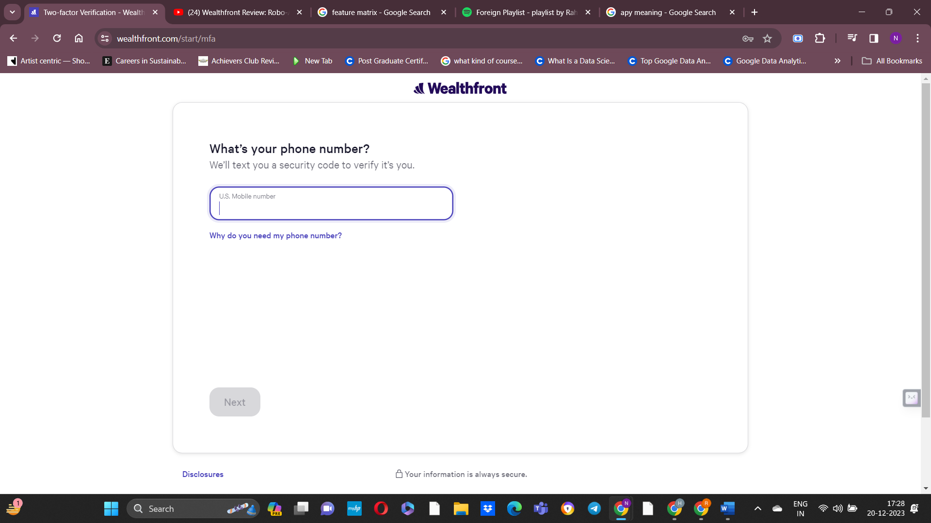

Inputs:

1. First name and Last name
2. Email and create password
3. US mobile number (for 2fa)
4. DOB
5. Income
6. Net Worth

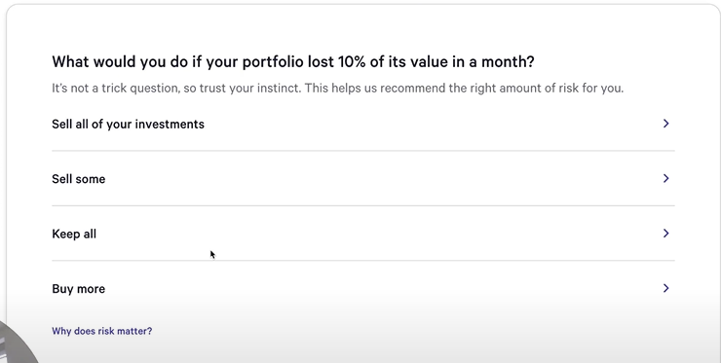

This is to calculate the amount of risk you should be taking

I chose buy more

8)

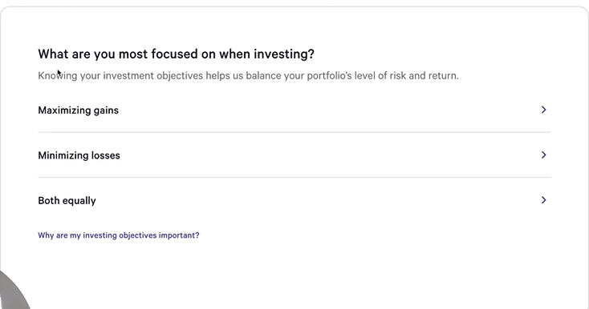

I chose maximizing gains

9)

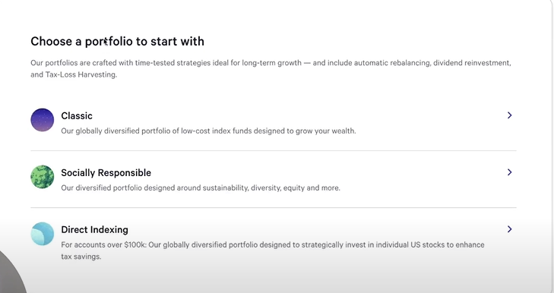

I chose classic

**Output:**

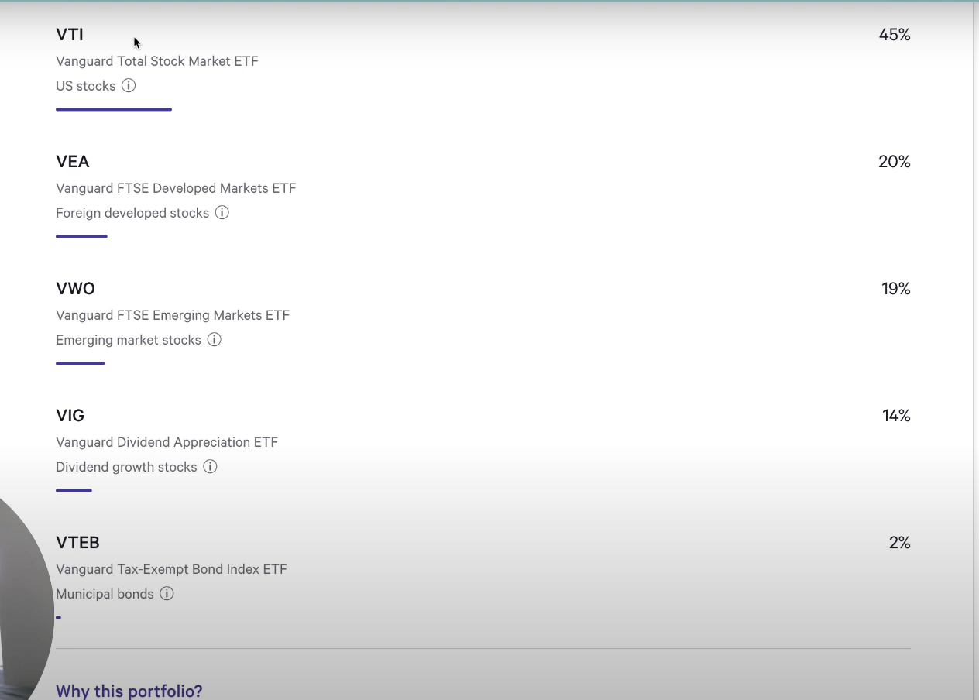

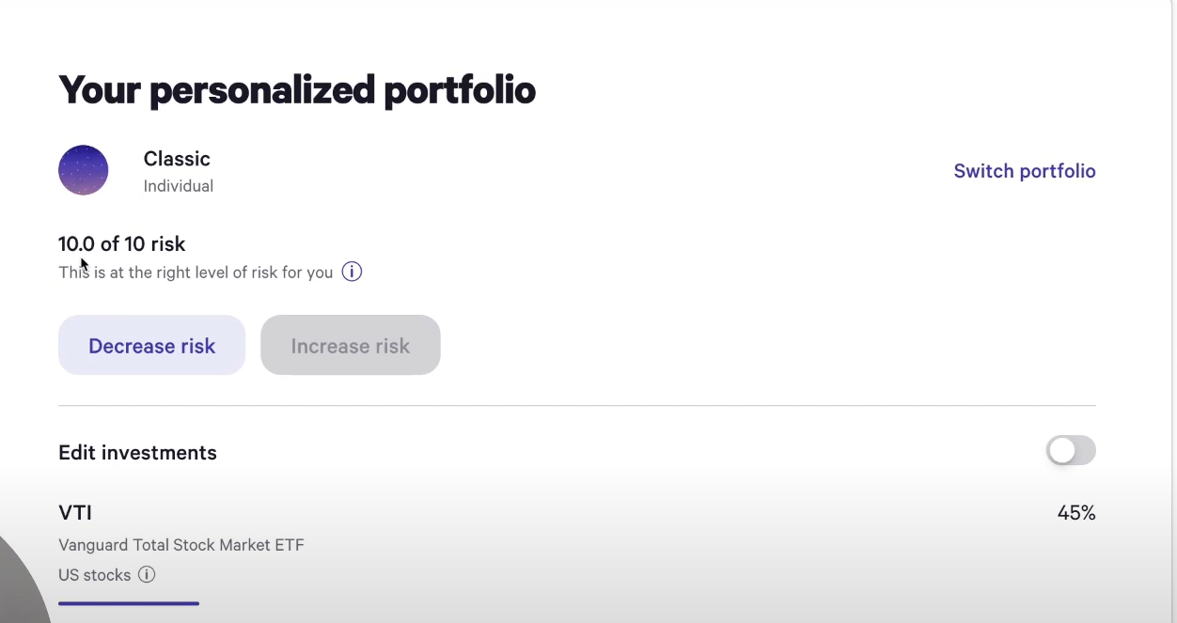

**Socially responsible portfolio:**

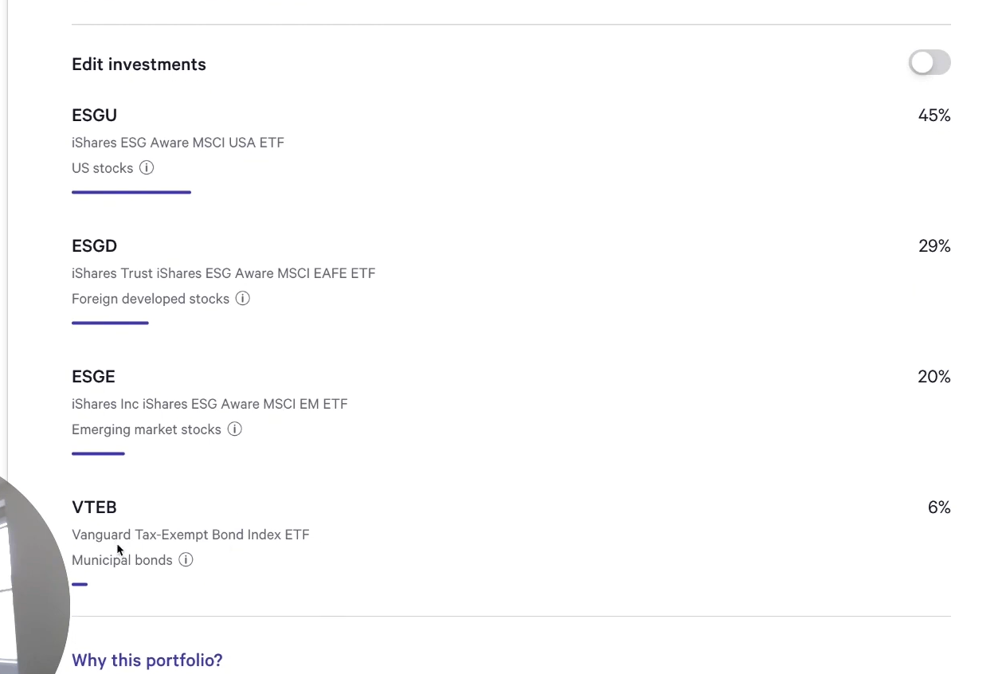

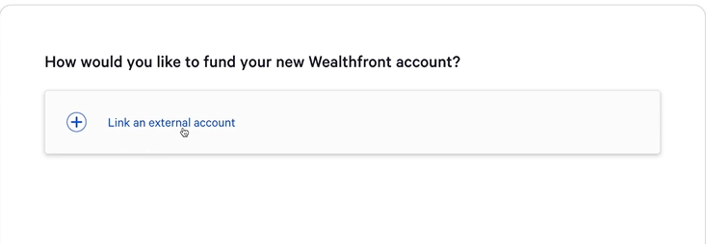

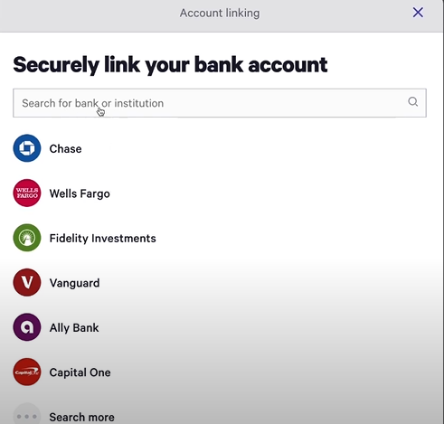

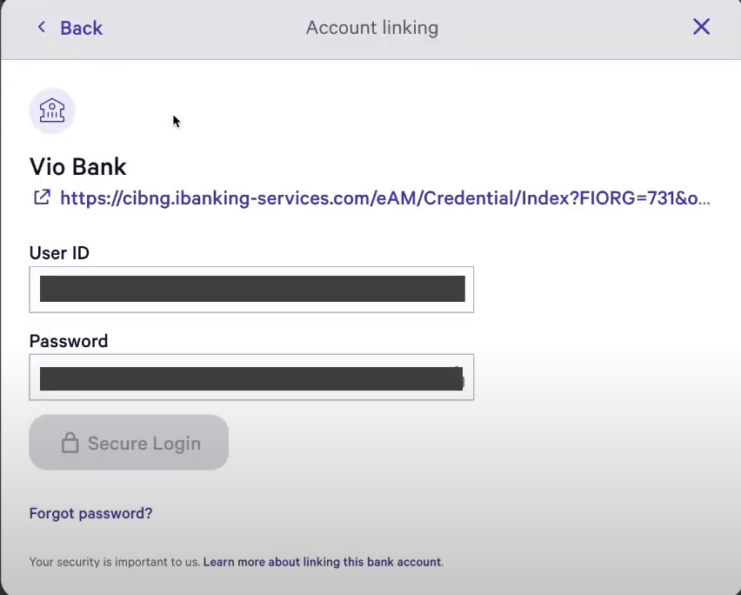

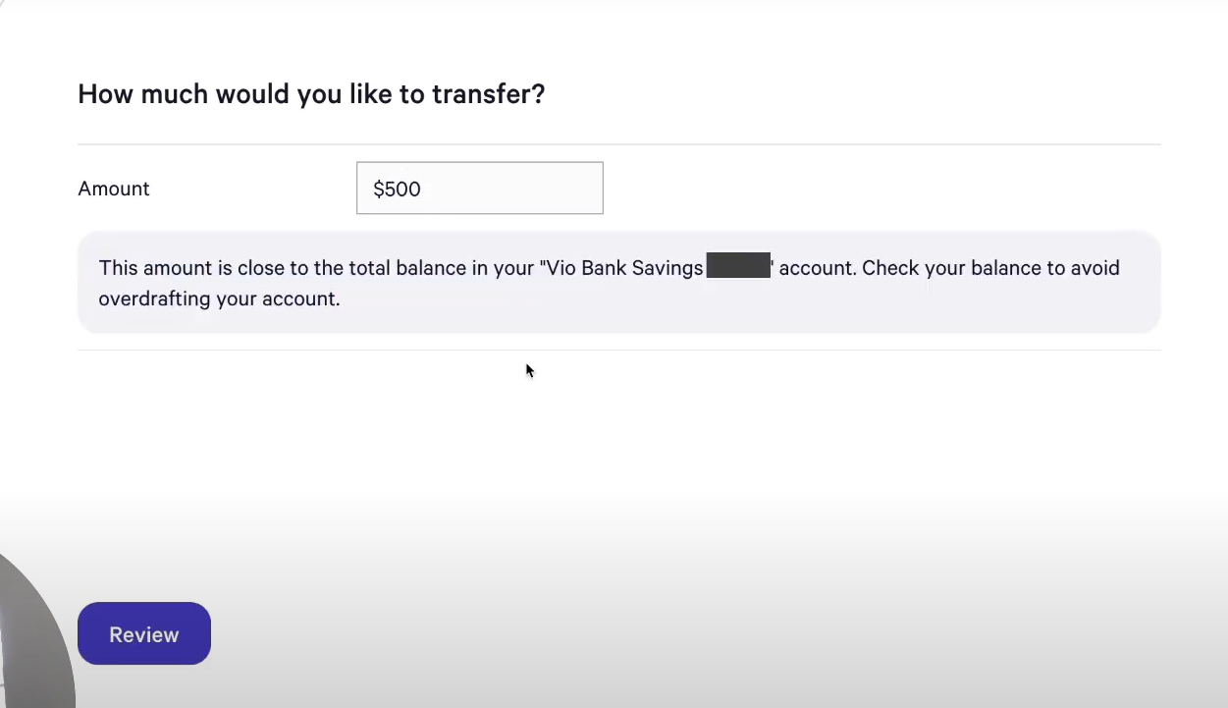

**The minimum initial deposit is 500$**

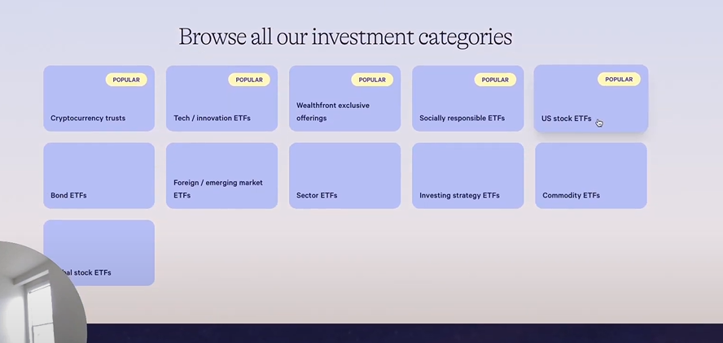

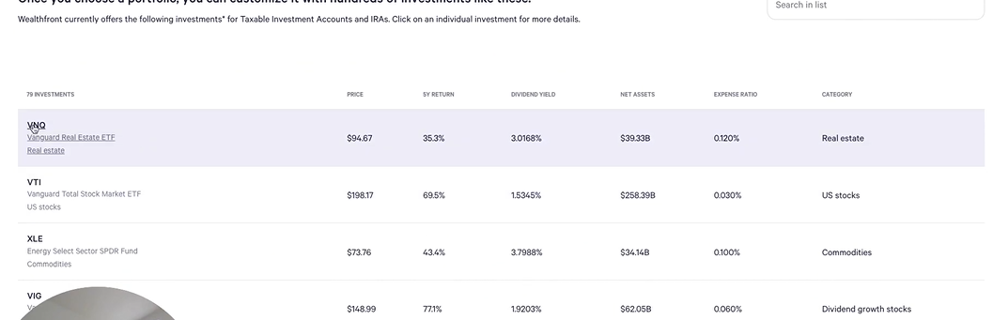

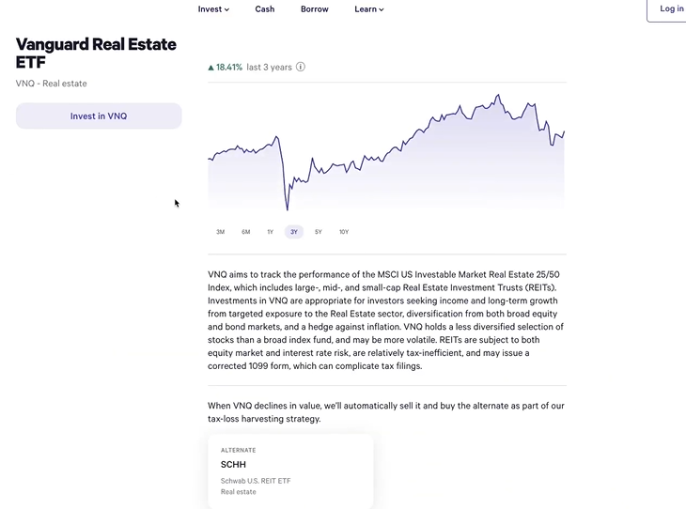

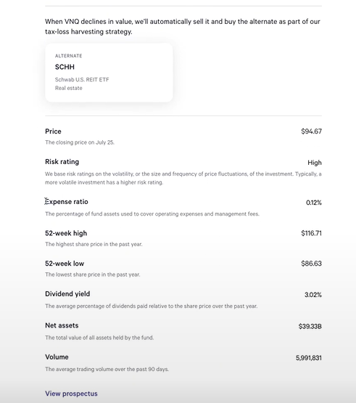

**So the expense ratio here indicated the additional percentage(excluding 0.25%) that you should pay to wealthfront if you are investing in this ETF**

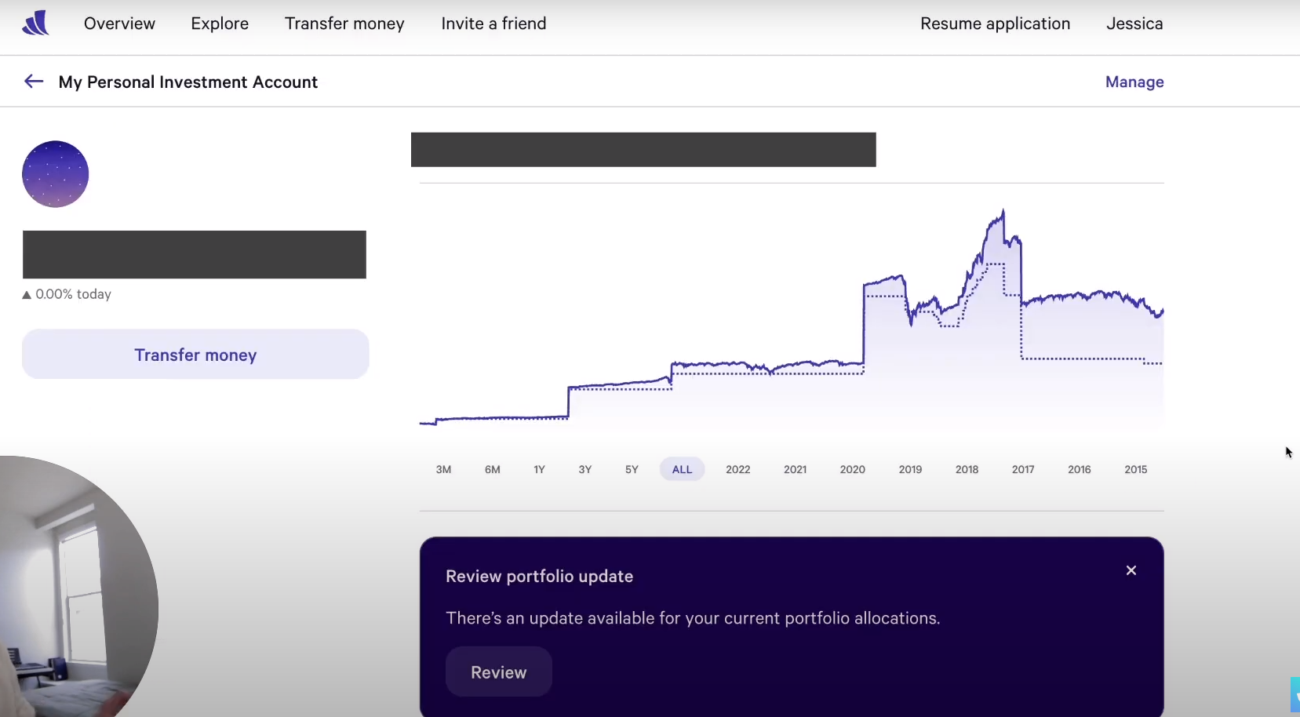

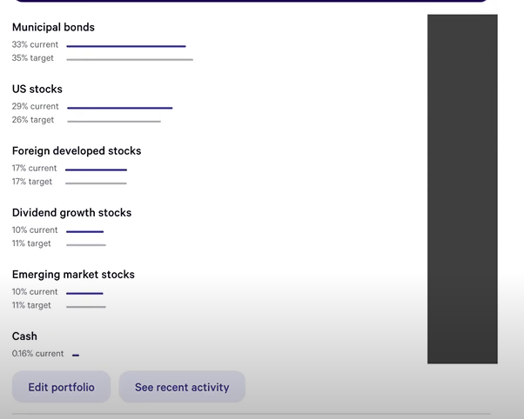

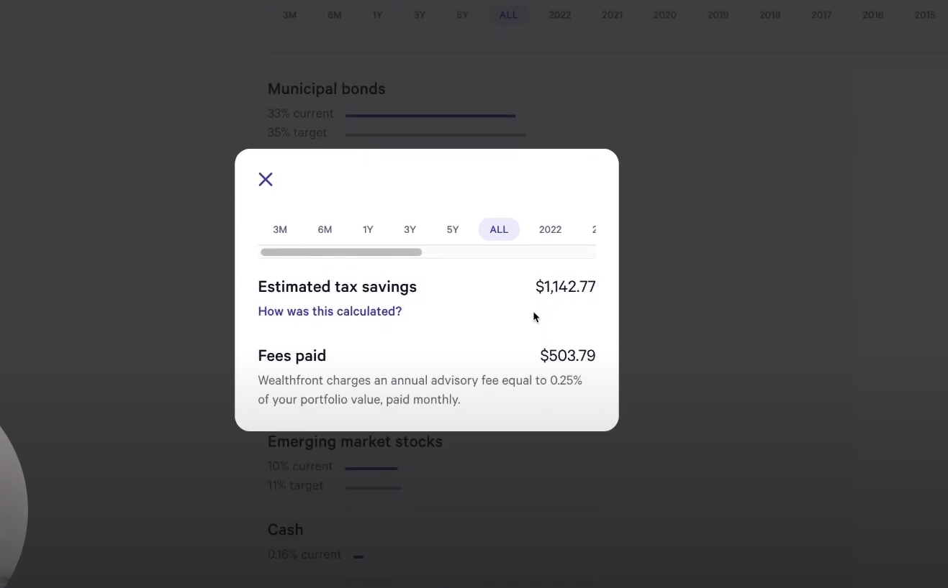

3 main features that wealthfront offers:

1. Free financial planning software
2. Tax-loss harvesting
3. Smart beta – available for portfolios above 500000$

Examples of Smart Beta 'Skills':

Value: Imagine finding bargain deals during a sale. In finance, smart beta might look for undervalued stocks that could be worth more in the future.

Quality: Think of picking reliable players for a team. Smart beta might choose companies with strong financial health and steady earnings.

Momentum: Like a player on a winning streak, smart beta might pick stocks that have been performing well recently, hoping they'll keep doing well.

Low Volatility: This is like choosing players who are consistent and don’t have extreme ups and downs. Smart beta might pick stocks that don’t swing wildly in value.

You have to pay 0.25% ofcourse to wealthfront

But portfolios below 100000$, you also have to pay 0.07 – 0.16% as fund fees. With direct investments, you don’t have to pay the fund fee

**Agile Software Development Plan for next 3 Sprints (Each Sprint of 2 weeks):**

**15th Dec to 31st Dec (1st phase):**

* Case Studies and Literature Survey
* Requirement gathering phase
* Feature analysis for different applications
* Feature Engineering & Requirement gathering for new Application to be developed

**1st Jan to 15th Jan (2nd phase):**

* Architectural design and planning
* Functional analysis of web application
* Backend, Frontend

**15th Jan to 31st Jan (3rd phase):**

* Technology finalizing and engagement (Tech Stack)
* Preparation of System Design Development.
* Documentation
* Future Scope of the Work for Development Phase.